Log into the FIFTH THIRD credit card portal at https://sdg2.53.com on Internet Explorer, the preferred browser for this portal. Bookmark this page for easy access.
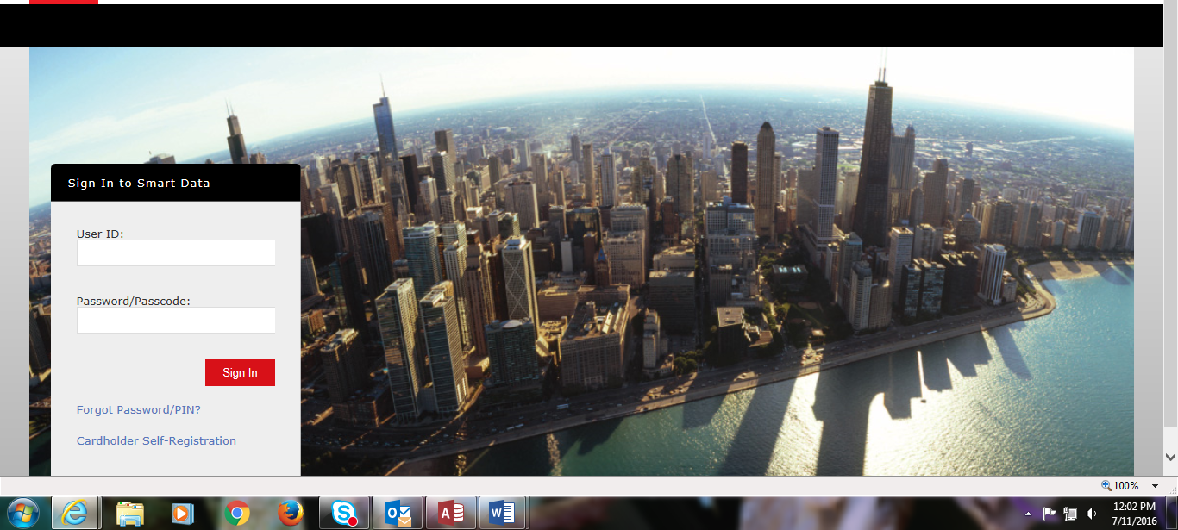

This is your home screen dashboard. To create an expense report, click Create Expense Report in the middle of the screen.
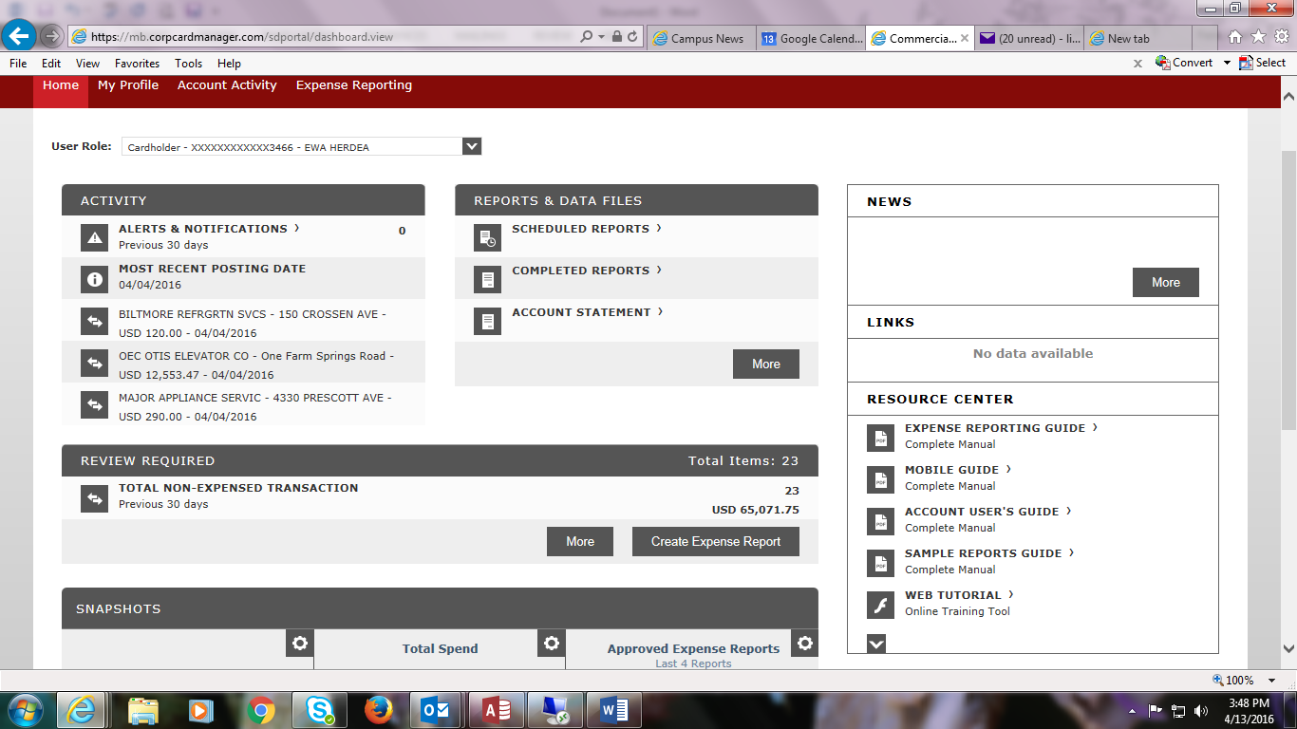
Under Report Description, replace the default name with your Name, Month, and Year, i.e., Adam Smeets July 2016
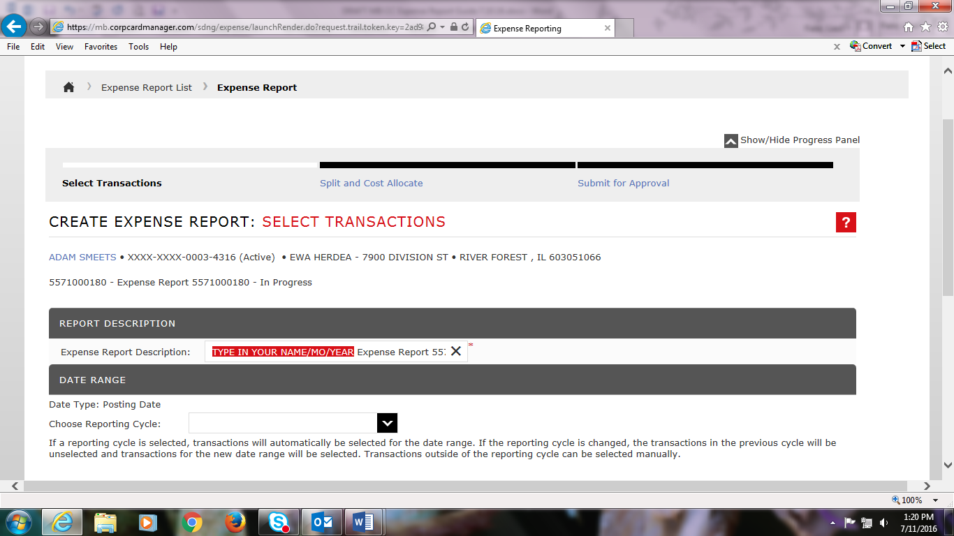

Click on the Reporting Cycle’s dropdown menu and select the appropriate month, i.e., July 2016.
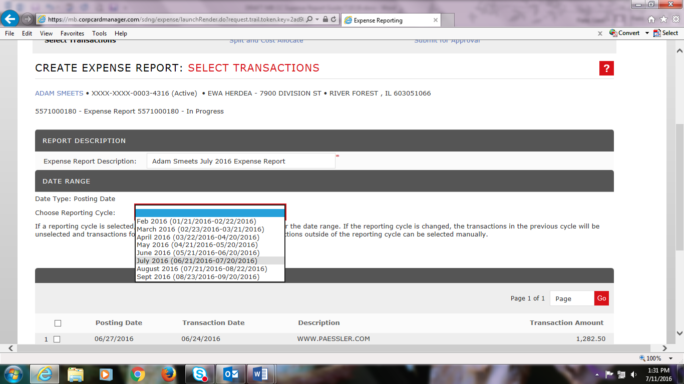

By choosing a reporting cycle, the system automatically selects transactions that fall within that date range – in this case 6/21/2016 – 7/20/16.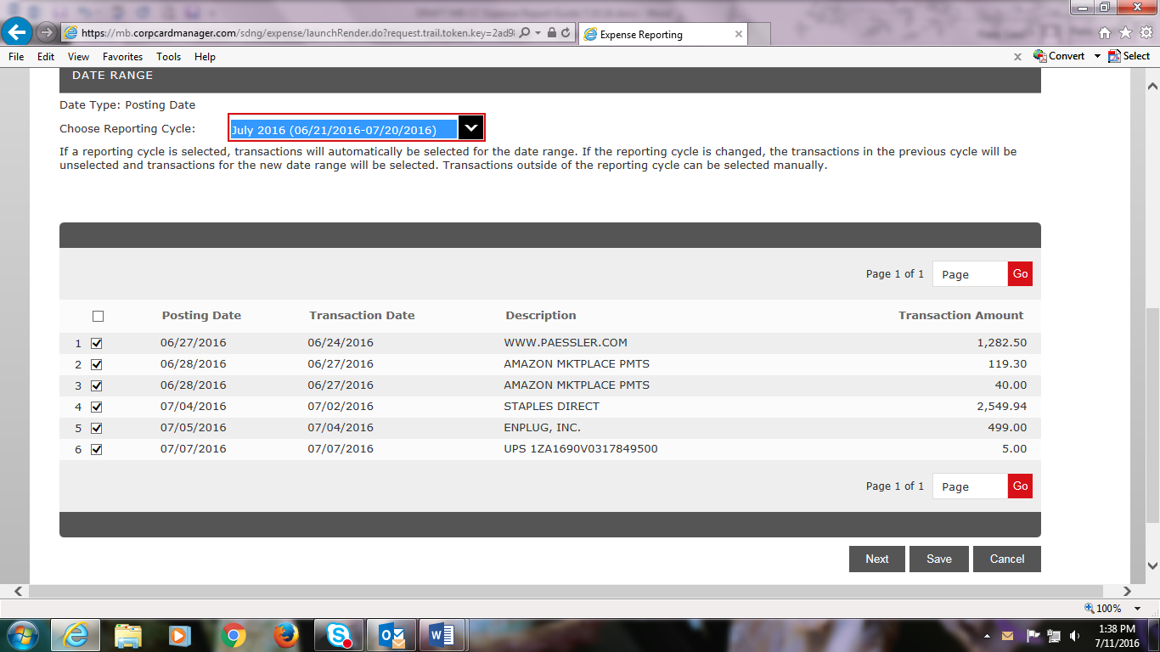

Click Next to go to the Split and Cost Allocate screen. This is where you will upload receipts/invoices, detail an expense description, and select the appropriate cost code(s); these are required in order to submit your expense report for approval. You can hover over icons to see a description.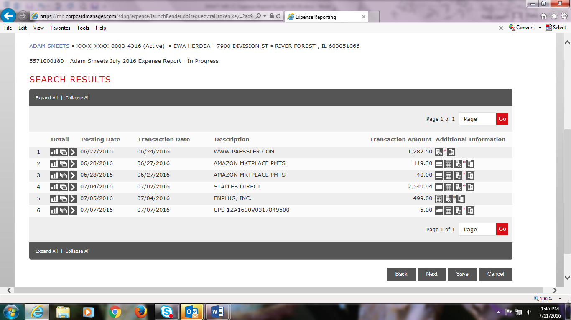
There are two ways to upload receipts: from your computer or from your phone. To upload from your computer, first scan your receipt/invoice and save as a pdf to your computer. On the right side of your transaction amount, click on the icon with a receipt and + sign to Add Receipt. (Mobile upload instructions are at the end of the guide.)
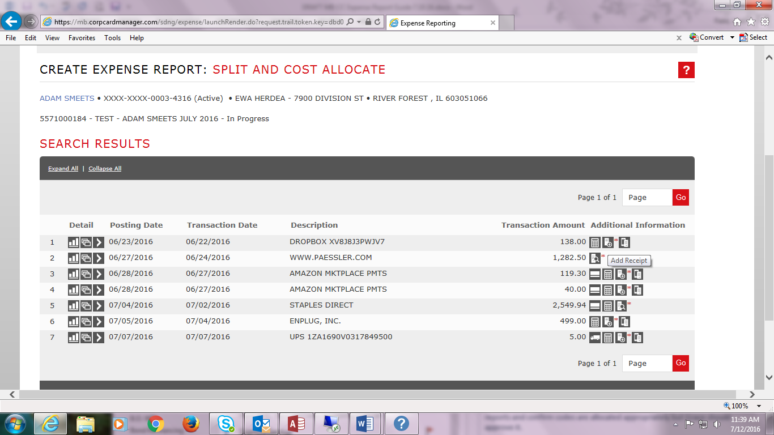

Click Browse to find your receipt and then click Add.
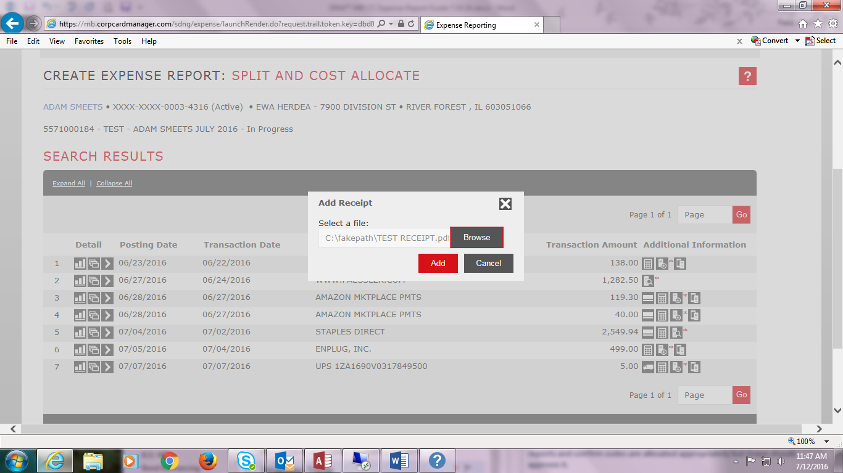
If you want to verify your receipt is correct, click on the Receipt + magnifying glass icon.
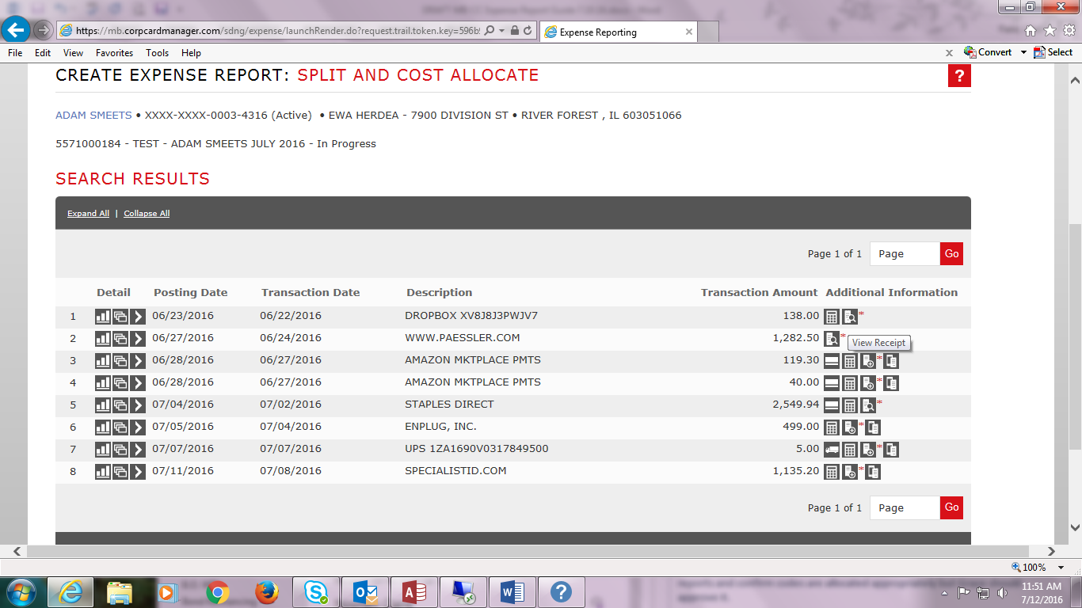

Click View.
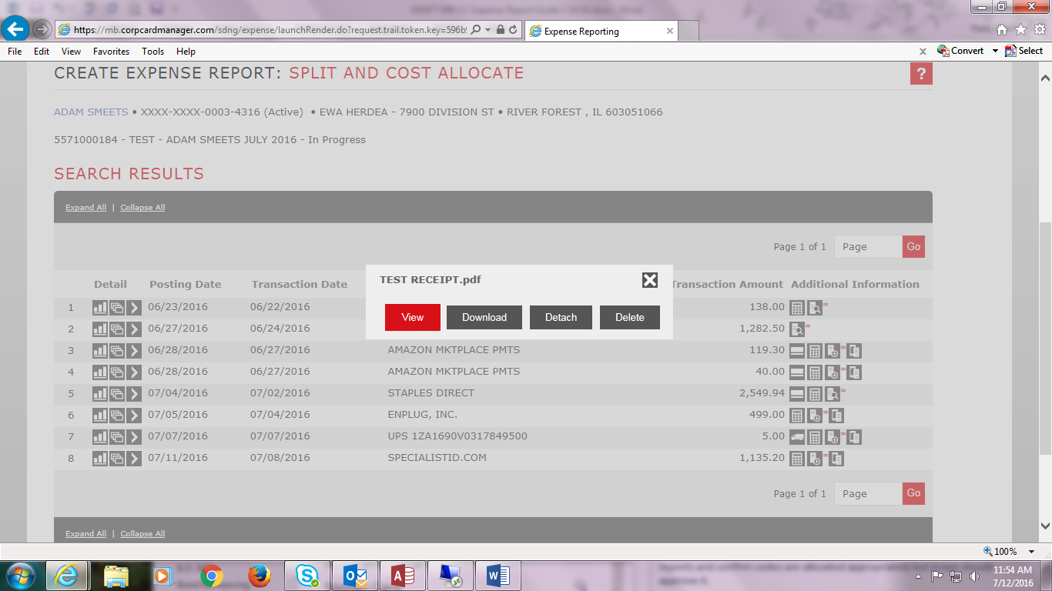

Your receipt/invoice will appear. Please ensure it has all required audit documentation. If missing a detailed receipt, go to the Business Office myDU webpage, download and complete the Missing Receipt Form, save it as a pdf, and attach it to your transaction.
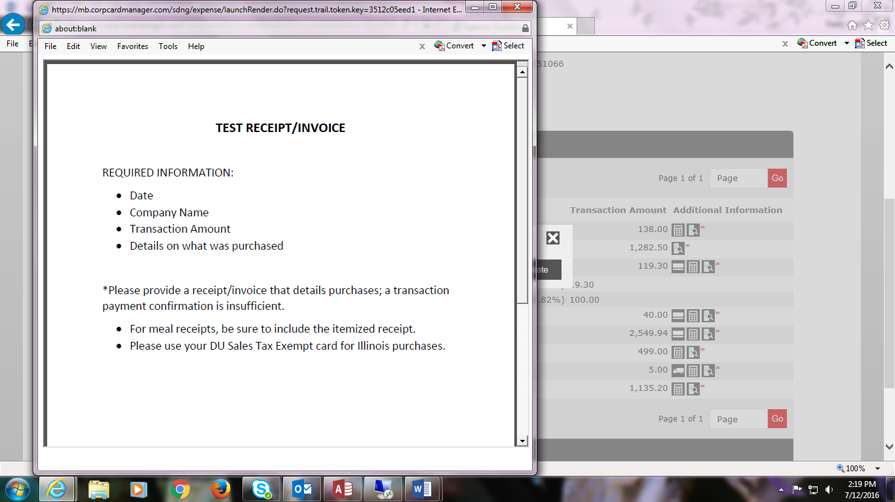

Click on the Accounting Detail > icon on the left side to cost allocate a transaction.
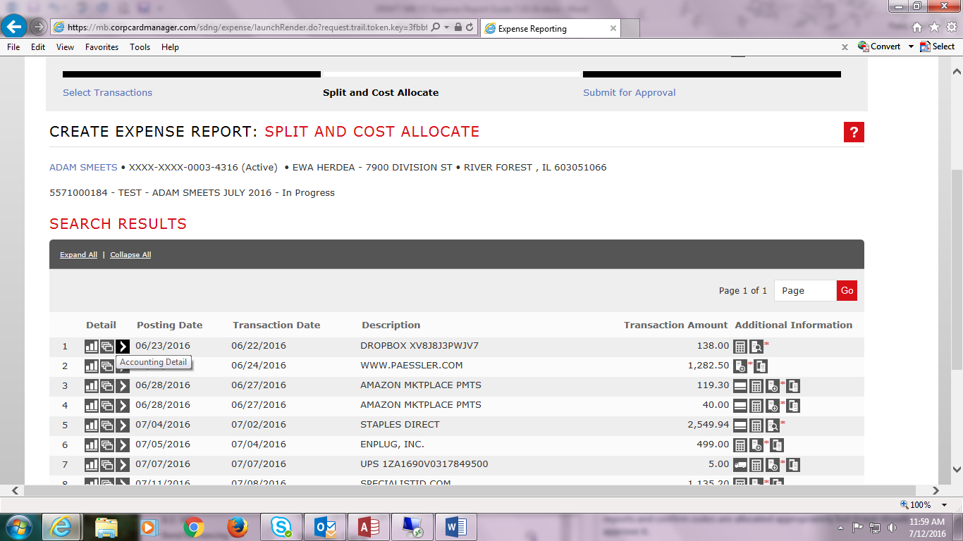
Enter an Expense Description. If the transaction is a business meal, you must detail the purpose of the meeting and individuals present per IRS regulations; for large groups, you can note the number in attendance. If a purchase is a partial shipment/cost and you upload the total order’s invoice amount, please note this in the description to account for the transaction amount difference.
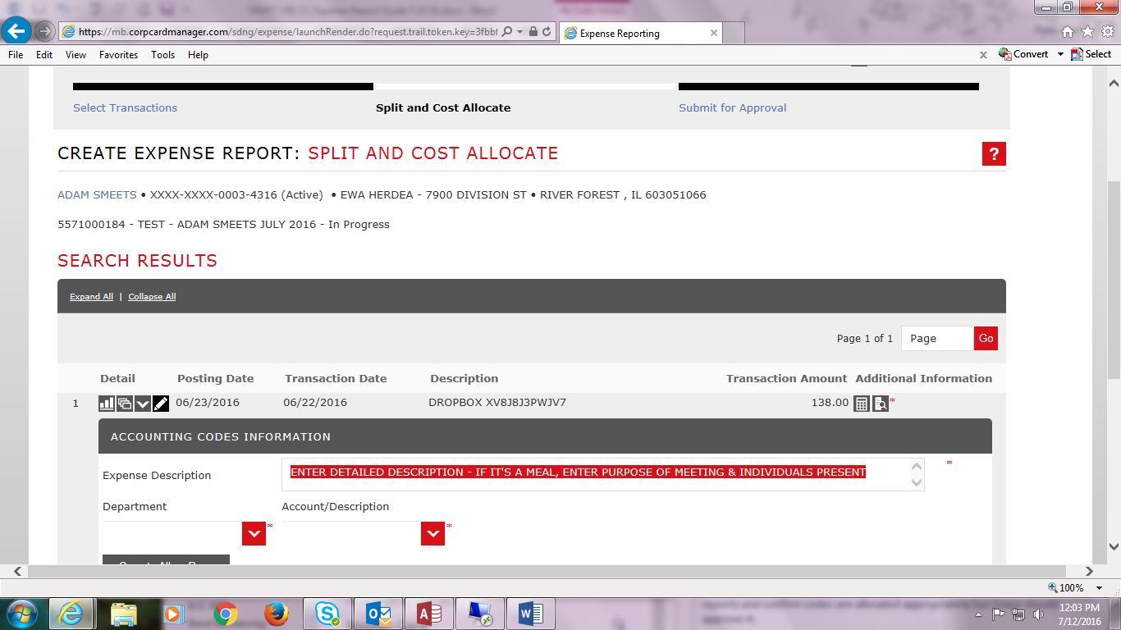

Click on the Department dropdown menu to select the appropriate department.
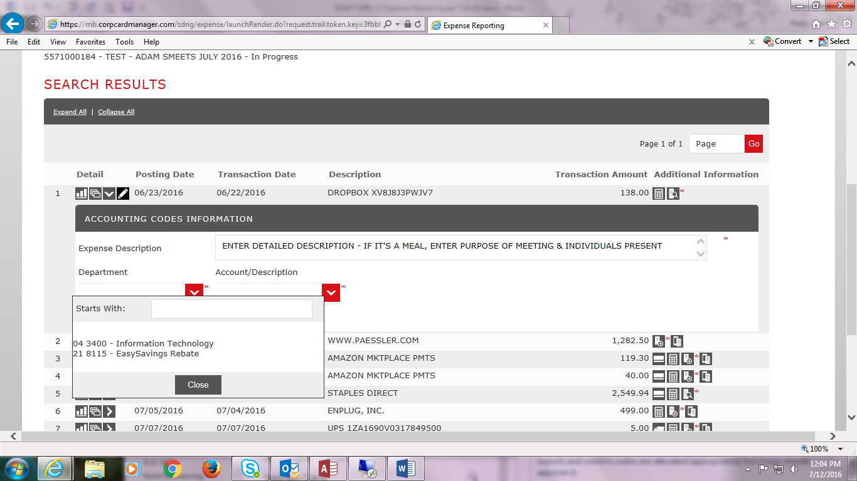
Then click on the Account/Description dropdown menu to select the appropriate account code. Scroll down or type in the code in the Starts With box. You are done cost allocating this transaction!
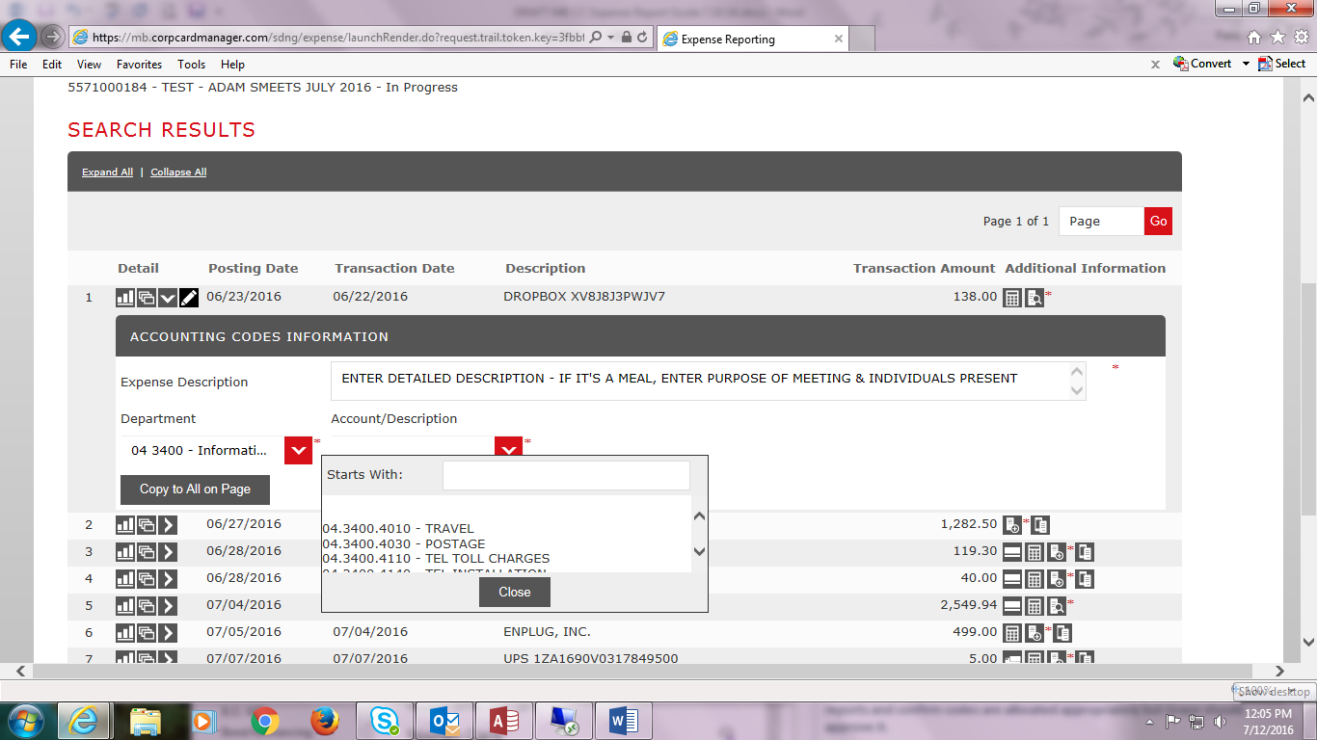

You can continue allocating and uploading receipts to other transactions or you can scroll to the bottom of the screen and click Save to work on it later.
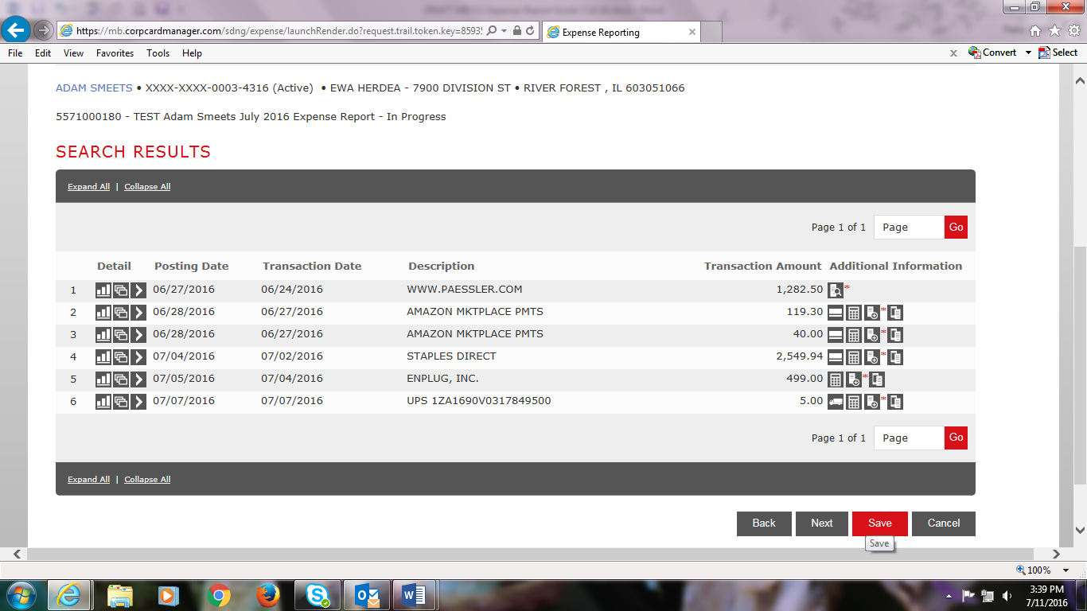

If you receive an EasySavings Rebate credit, which will show as RBT and the Merchant Name, select EasySavings Rebate under Department and the DU Financial Hardship code under Account/Description.
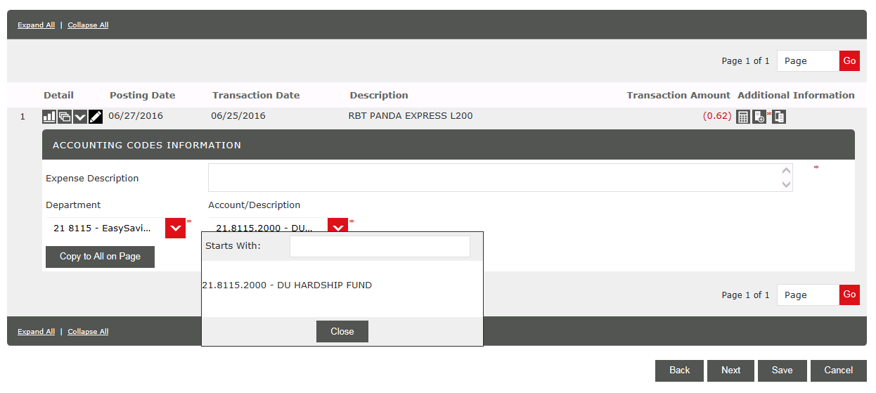

Please note: In order to save your expense report you must have a transaction fully allocated/uploaded otherwise it will give you an error message detailing what required field is missing.
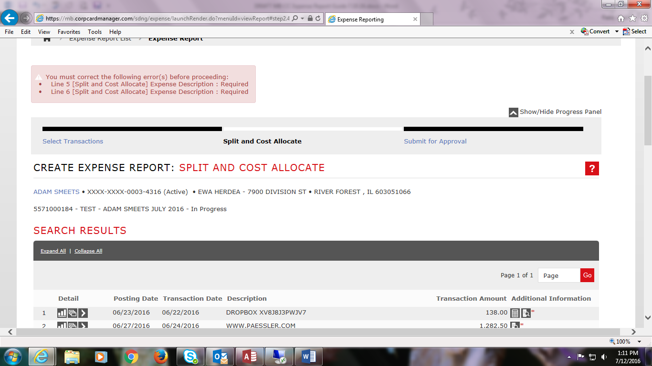

Click Edit Accounting Code to enter the missing Description.
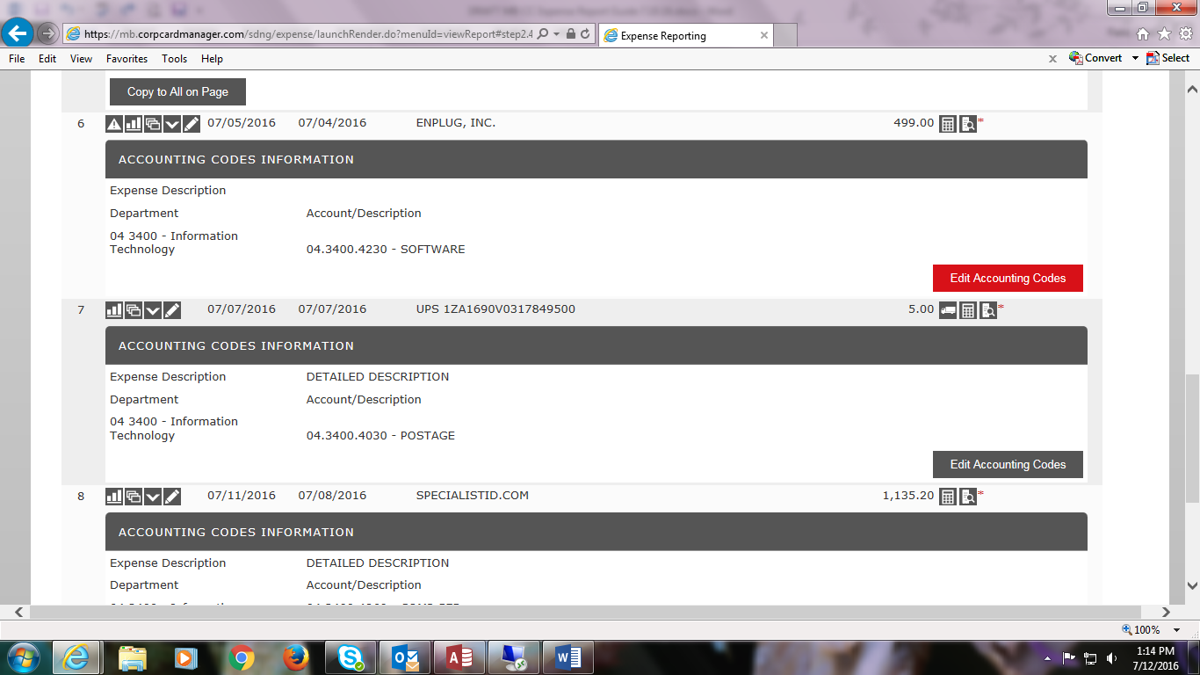

We recommend that you Add Receipts first to each transaction before cost allocating to prevent confusion on which transaction you are working on. You can look to the left-hand number to identify which transaction you are allocating. The receipt icon appears above the transaction detail.
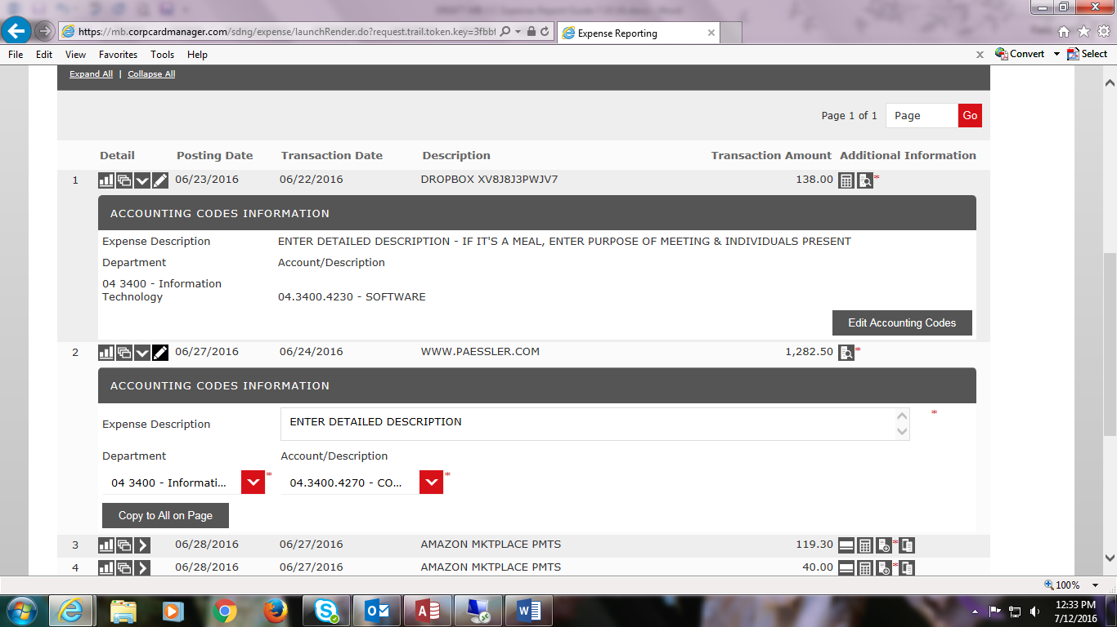

Click the > to open or the ^ to close the Accounting Detail of each transaction.
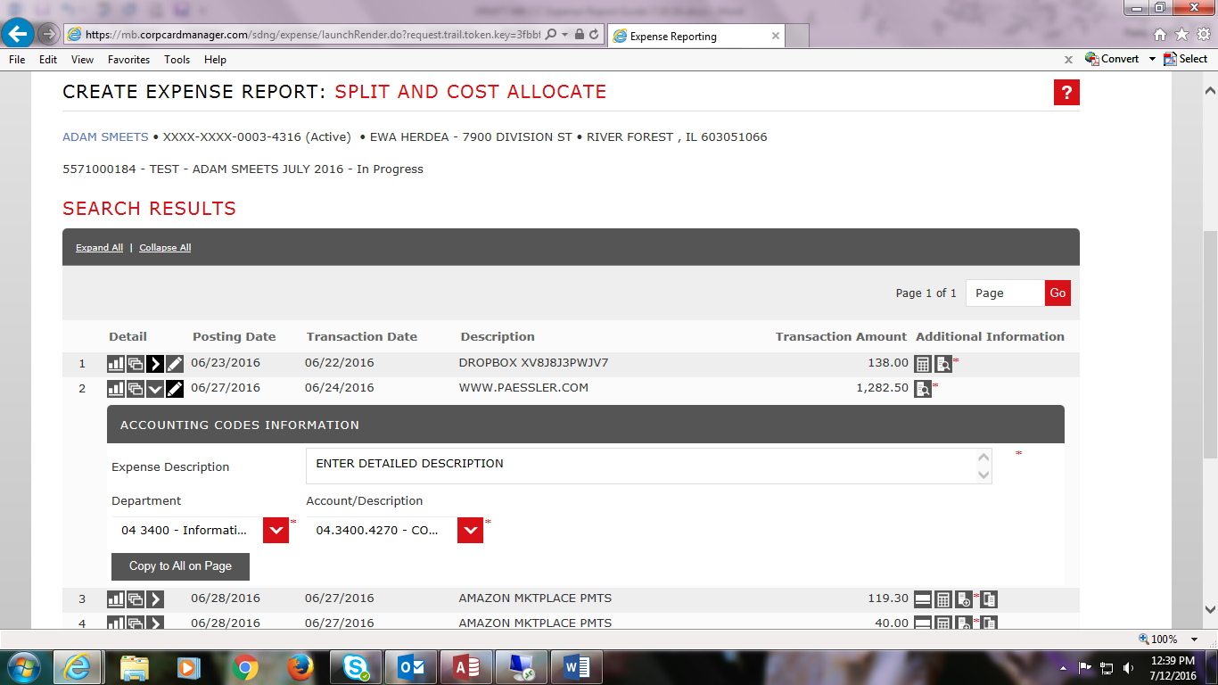

If you need to change a transaction’s cost allocation, click Edit Accounting Codes
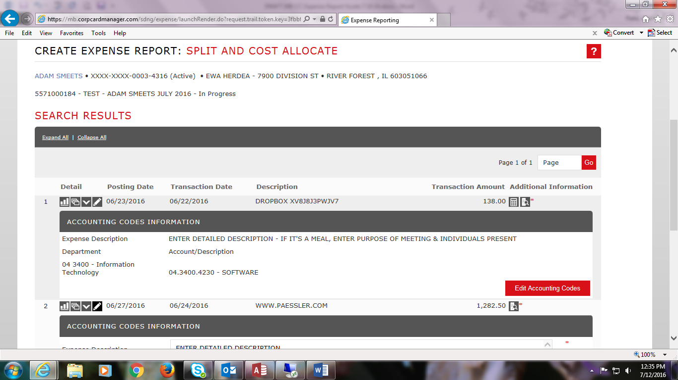

Splitting Transactions: If you need to split a transaction’s cost to different account codes, click on the cascading windows Split Transaction icon next to the > icon.
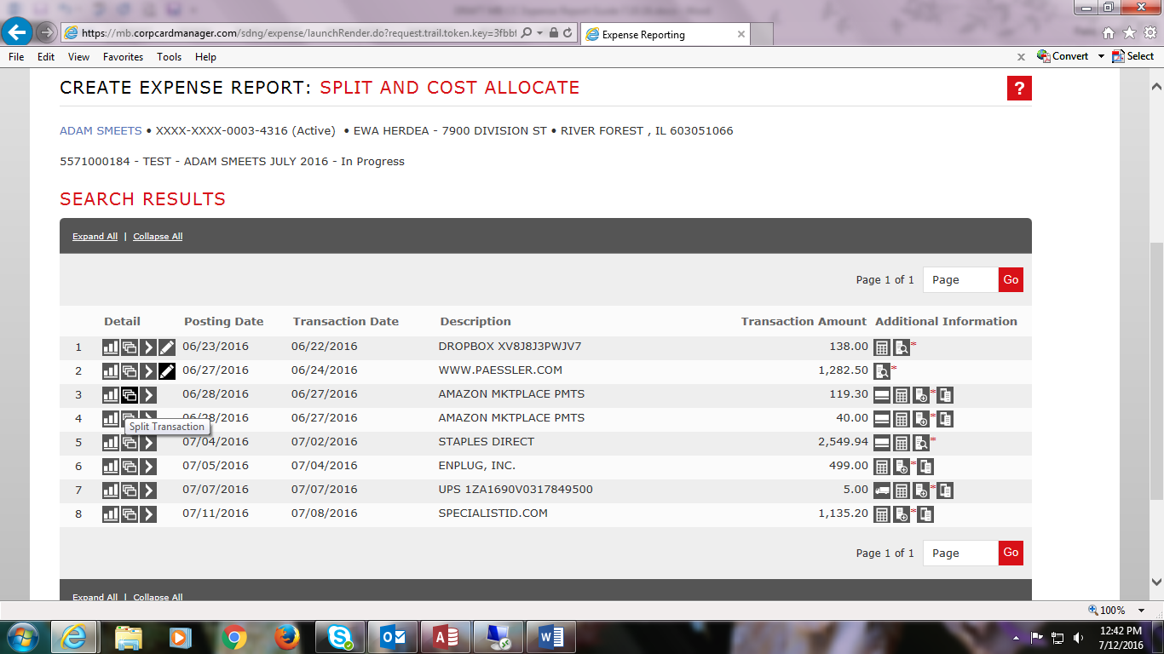

This is the Split Transaction screen. Click the Add Receipt icon under Additional Information to attach a receipt. It is important to Add Receipt first when splitting transactions in order to save it correctly.
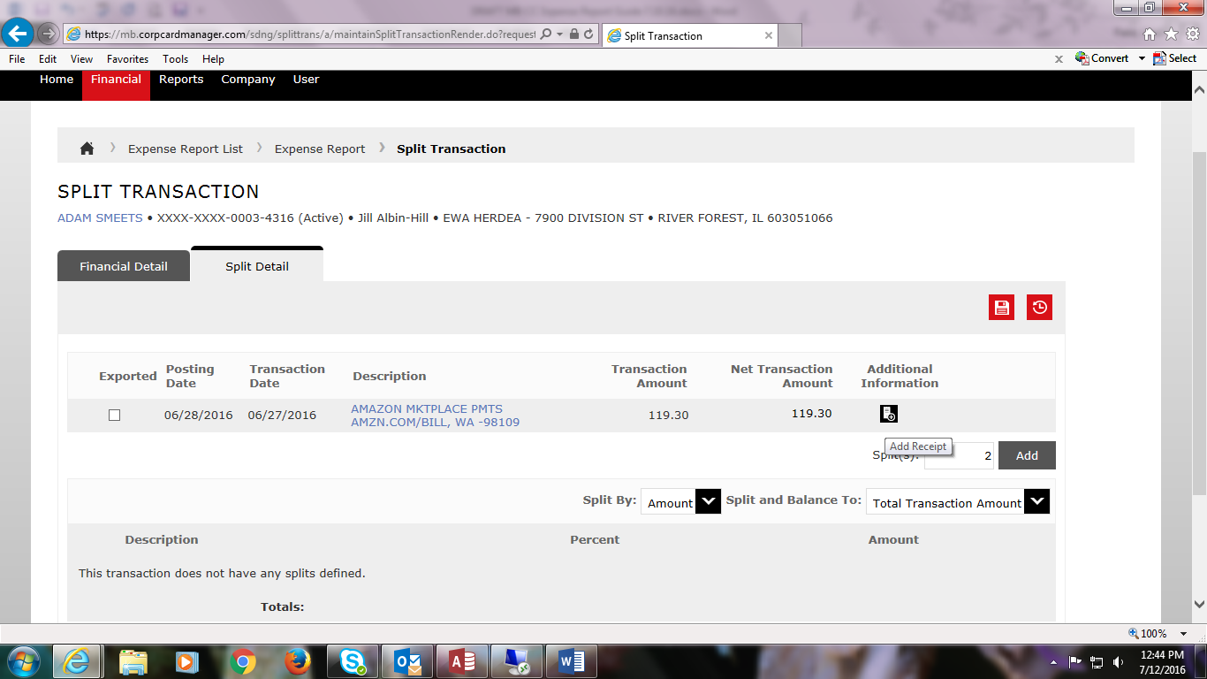

Click the Save icon on the top right hand side.
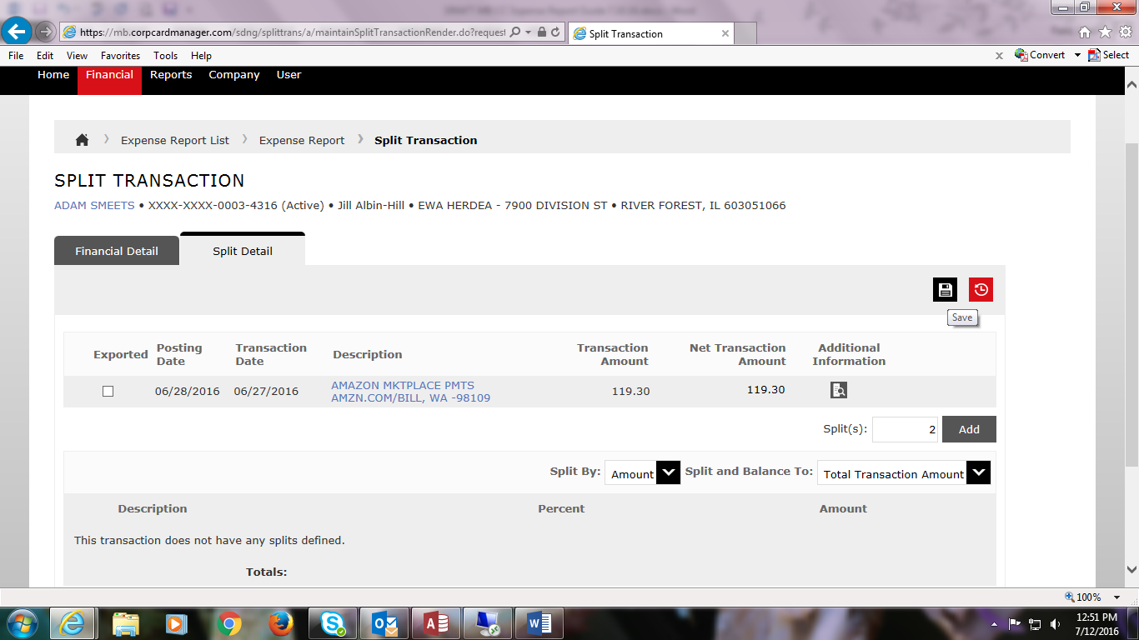

Select the number of splits and if you want the split by Amount or Percent. Click Add.
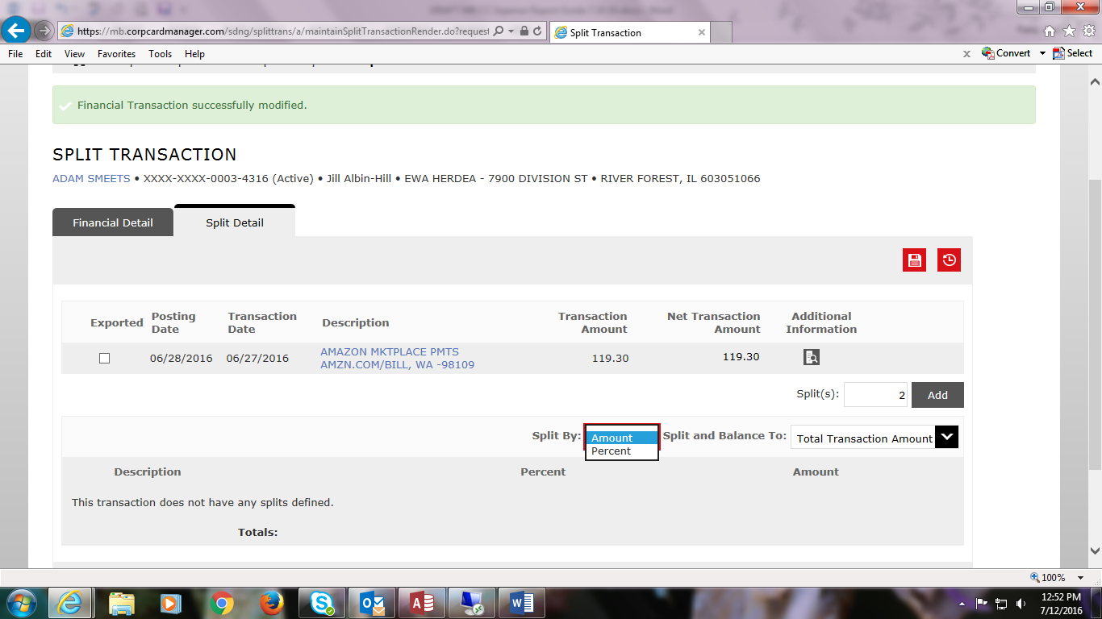

This screen shows 2 splits by Amount. Enter the Expense Description per Split and edit the amounts as needed.
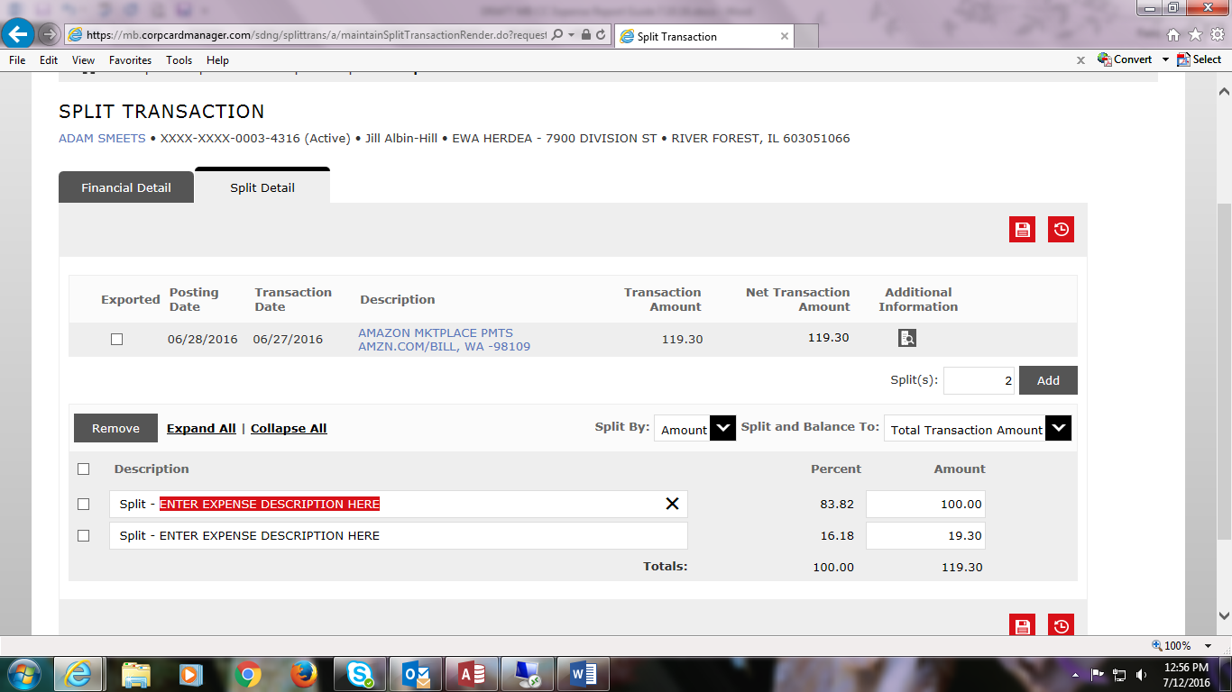

This screen shows 2 splits by Percent. Enter the Expense Description per Split and edit the Percent as needed.
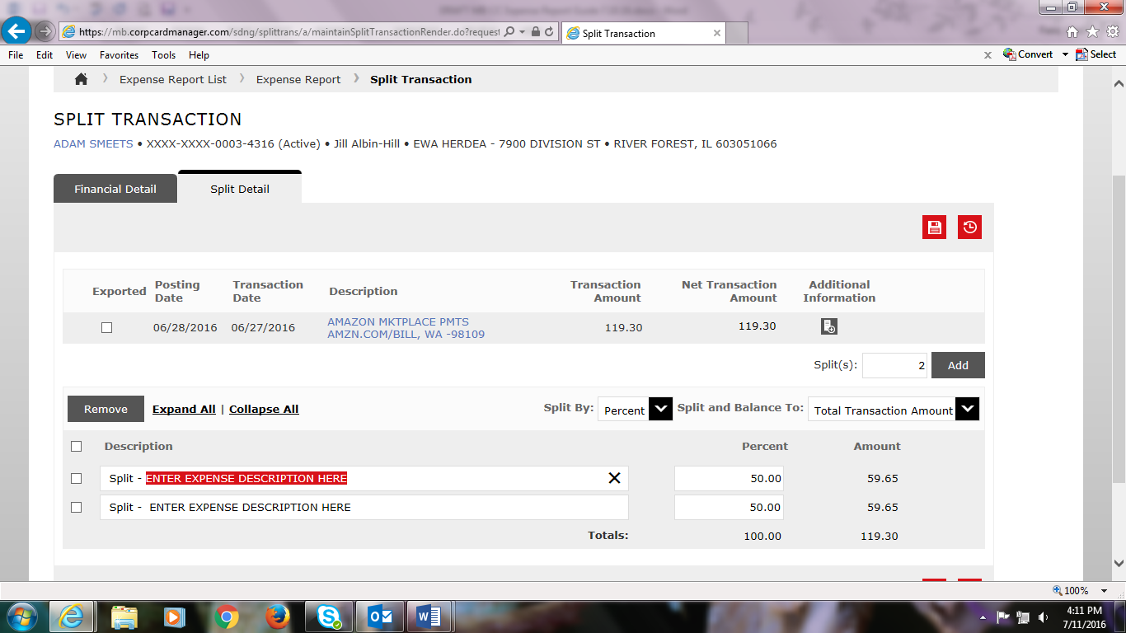

Click the Save icon at the bottom right. You can now cost allocate the Split Transactions.
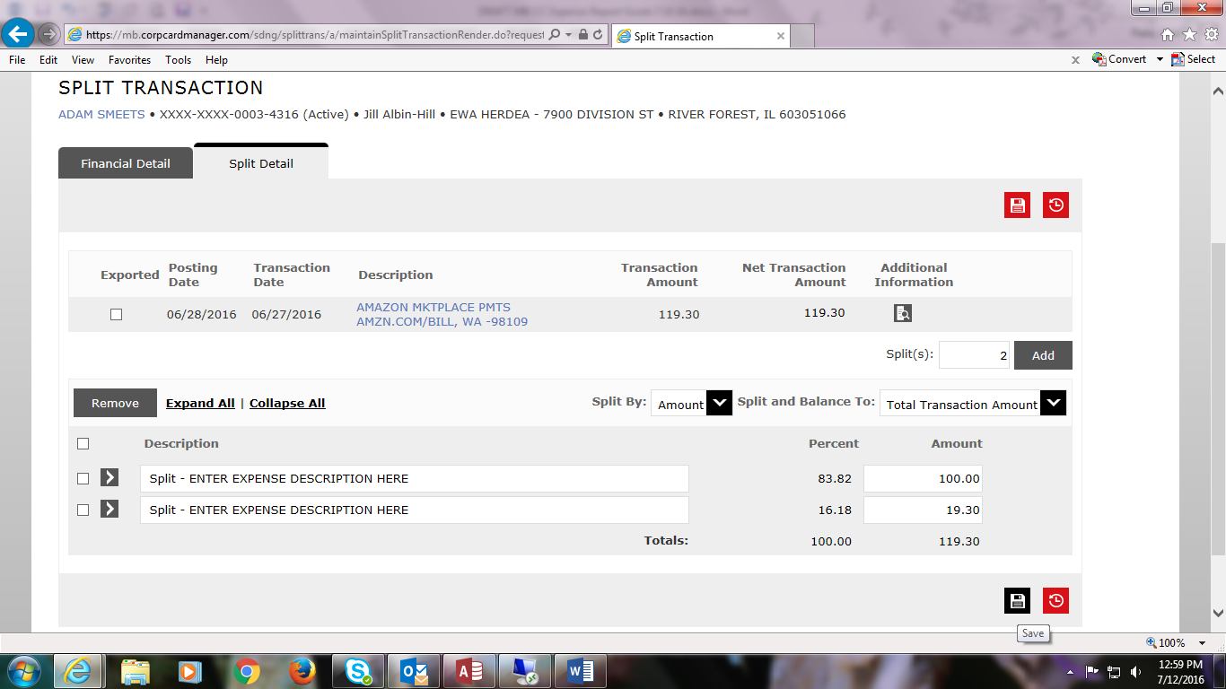

Click on the > icon to view this cost allocation screen. Select the appropriate Department and Account/ Description code from the dropdown menus. Be sure to scroll down and cost allocate each split.
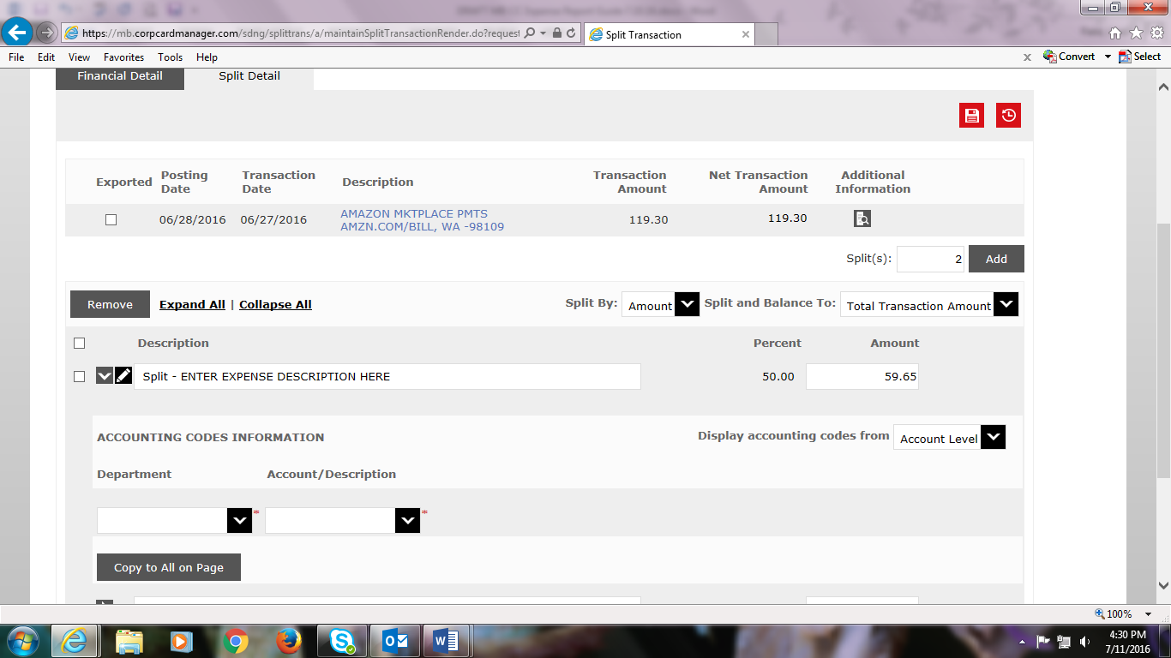

Click Save.
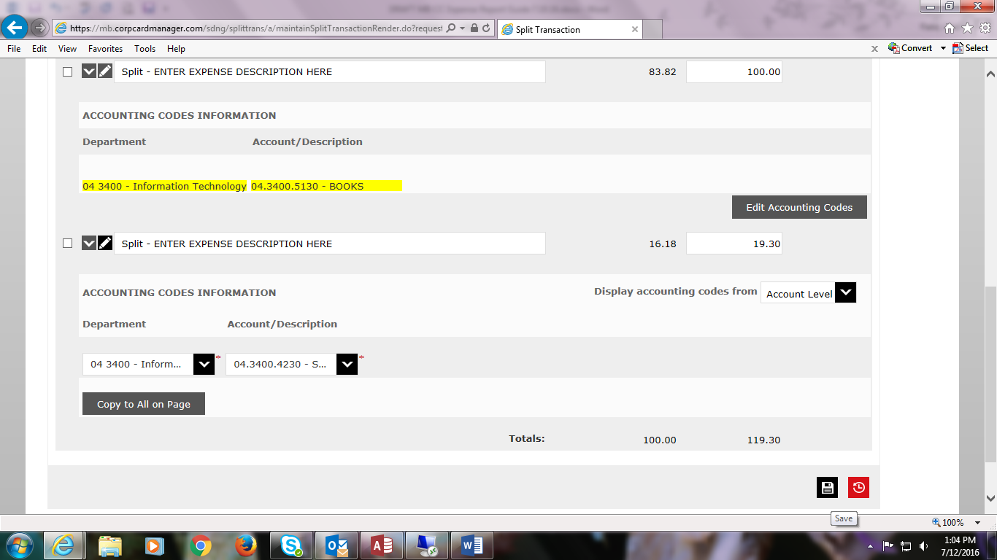

To return to your expense report, scroll to the top of your screen and next to the top left House icon, select Expense Report.
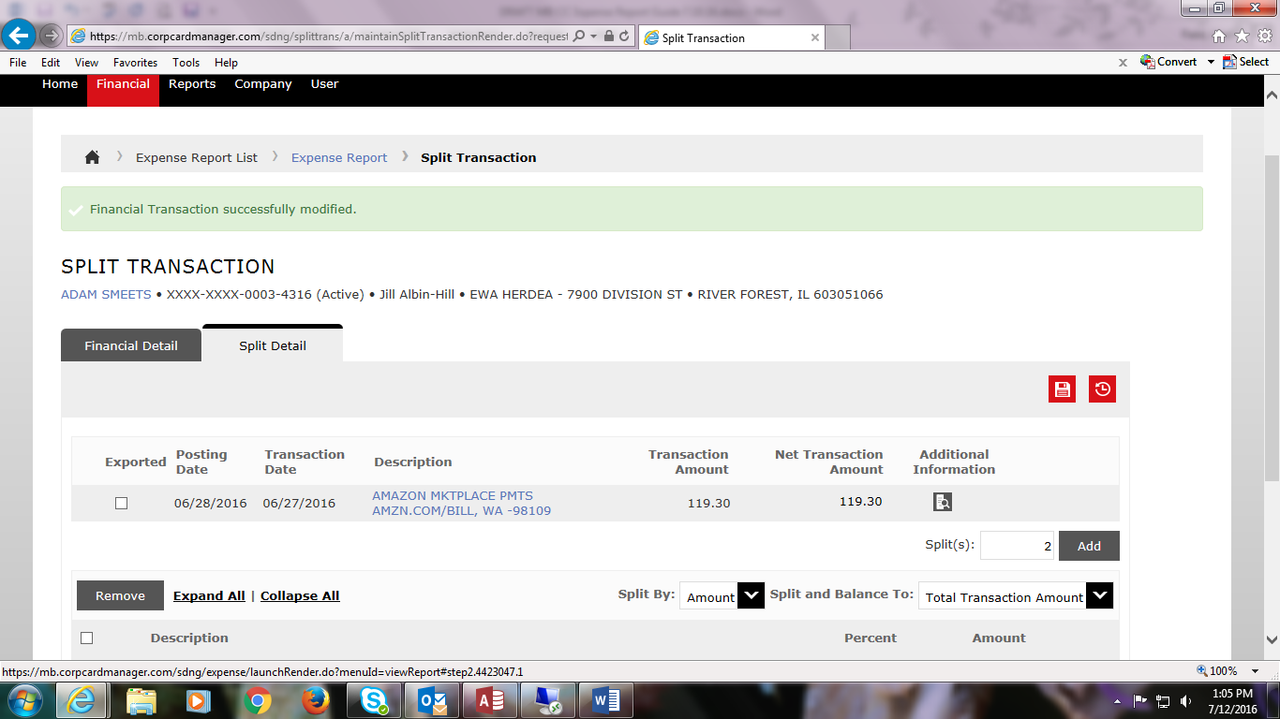
To quickly check if you have allocated and uploaded all transactions, click on Expand All on the left side and scroll down to see if all transactions are complete with an Expense Description and codes. Scan the receipt icon to confirm you see a receipt with a magnifying glass instead of a + sign.
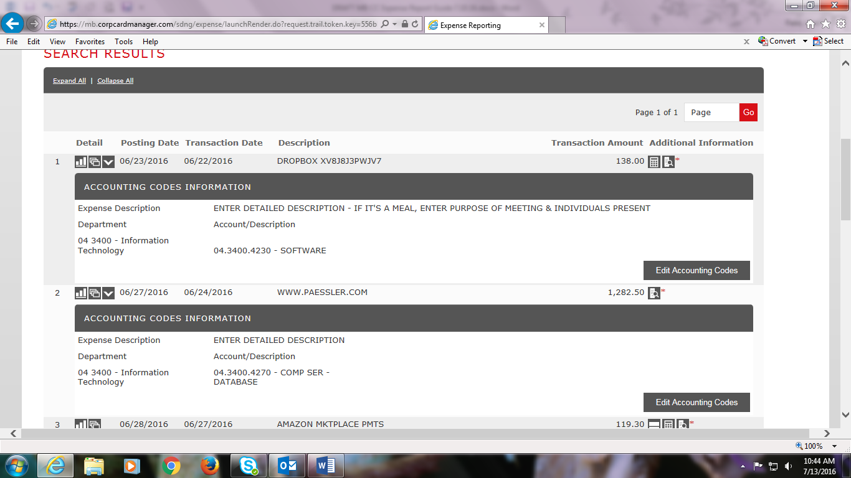

When all transactions are cost allocated appropriately and have uploaded receipts, click Save. 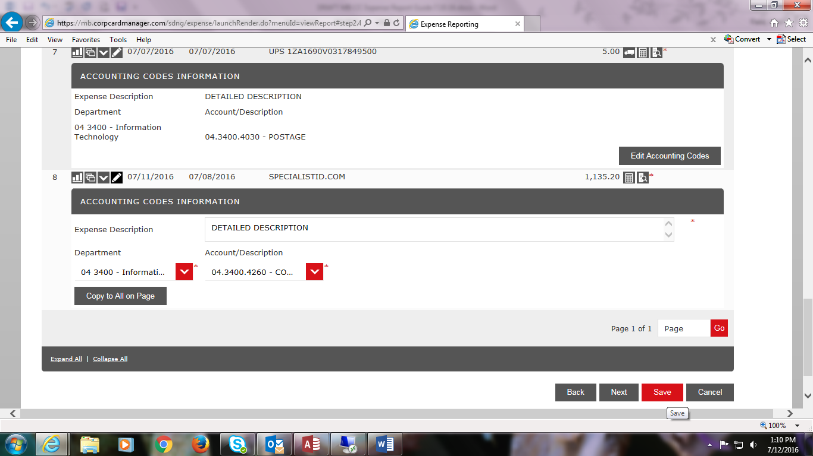

You are ready to submit your expense report.
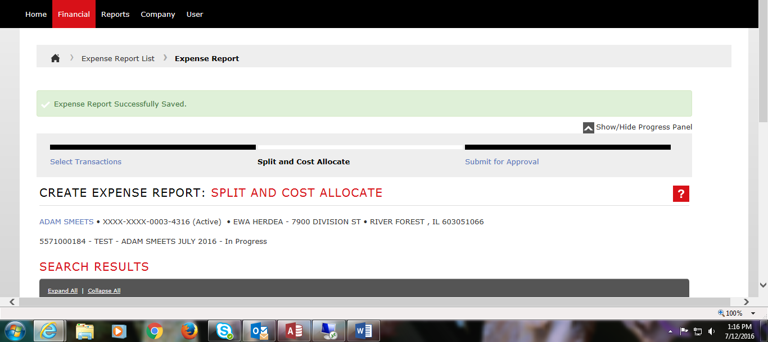

Scroll to the bottom of the screen and click Next.
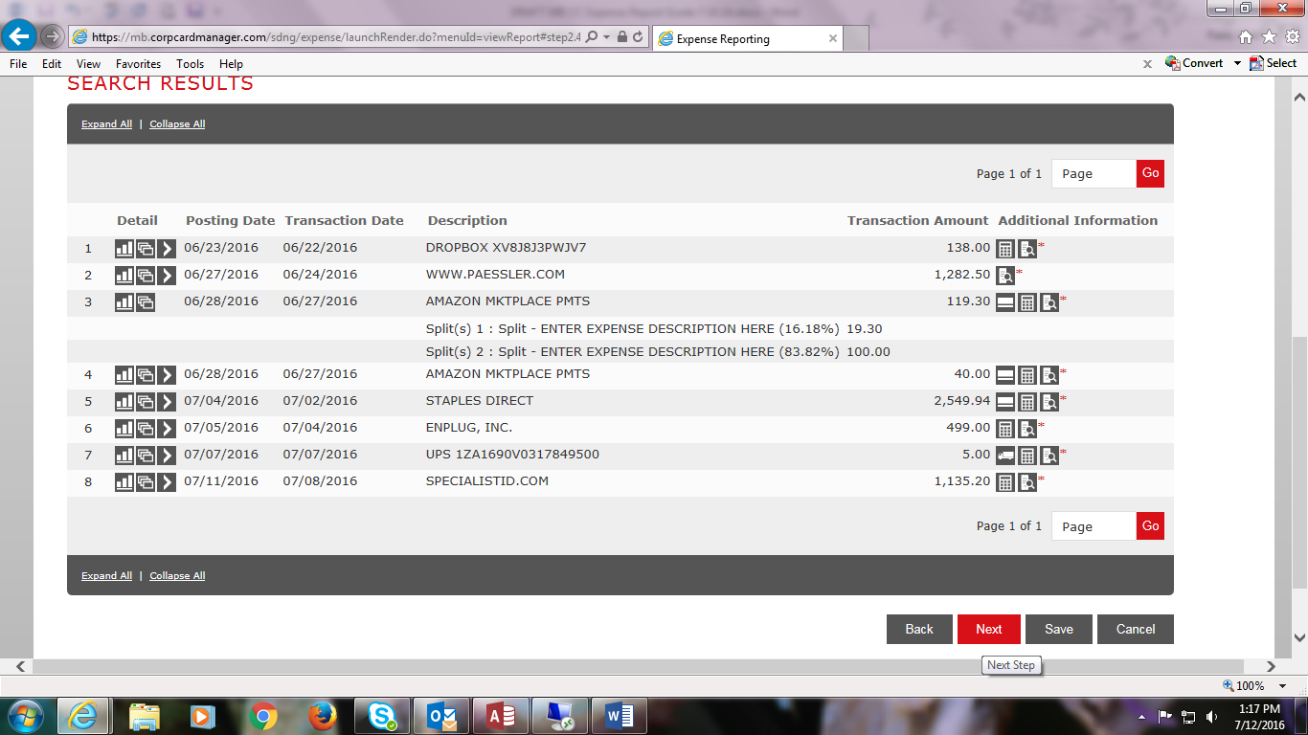

You will see a summary of your transactions. Click Submit.
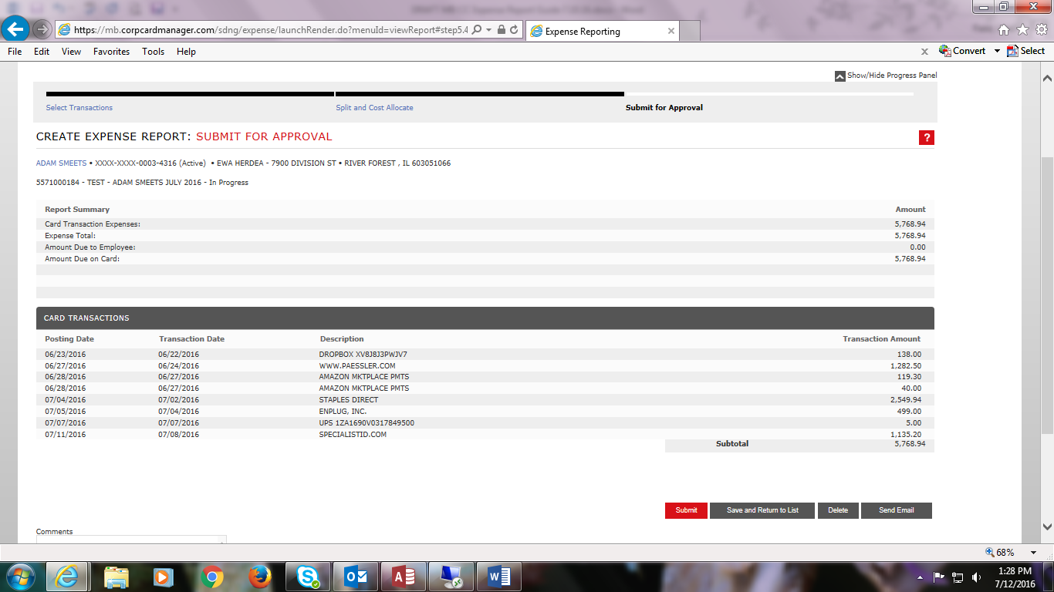

Click OK to confirm that you want to submit your expense report. 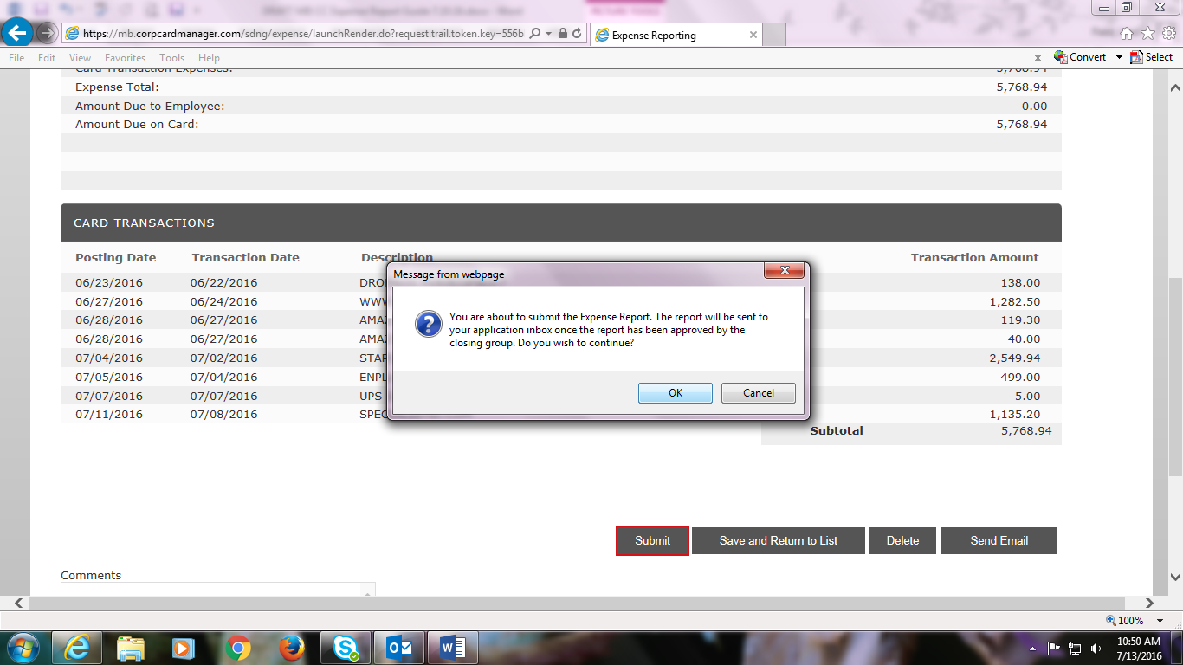

You and your supervisor will receive an email notification from FIFTH THIRD Financial that an Online Expense Report has been Submitted for Approval. It is generic and cryptic; to avoid phishing scams, do NOT click the link. Instead, please go to Internet Explorer and access the FIFTH THIRD portal via your bookmarked page.
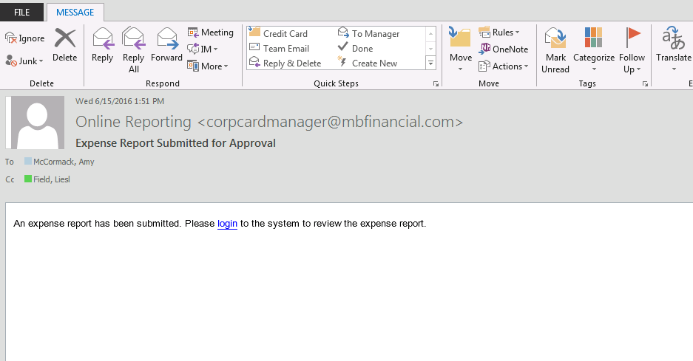

Supervisor approval: Log into the FIFTH THIRD portal when you receive the email notification that an Expense Report is ready to approve. If you are also a credit cardholder, there will be a dropdown menu at the top of your screen. Click on it to select Level Manager instead of Cardholder. You will see the submitted expense report under Review Required. Click on the expense report. If there are more than one, click on the More button to see other reports to approve.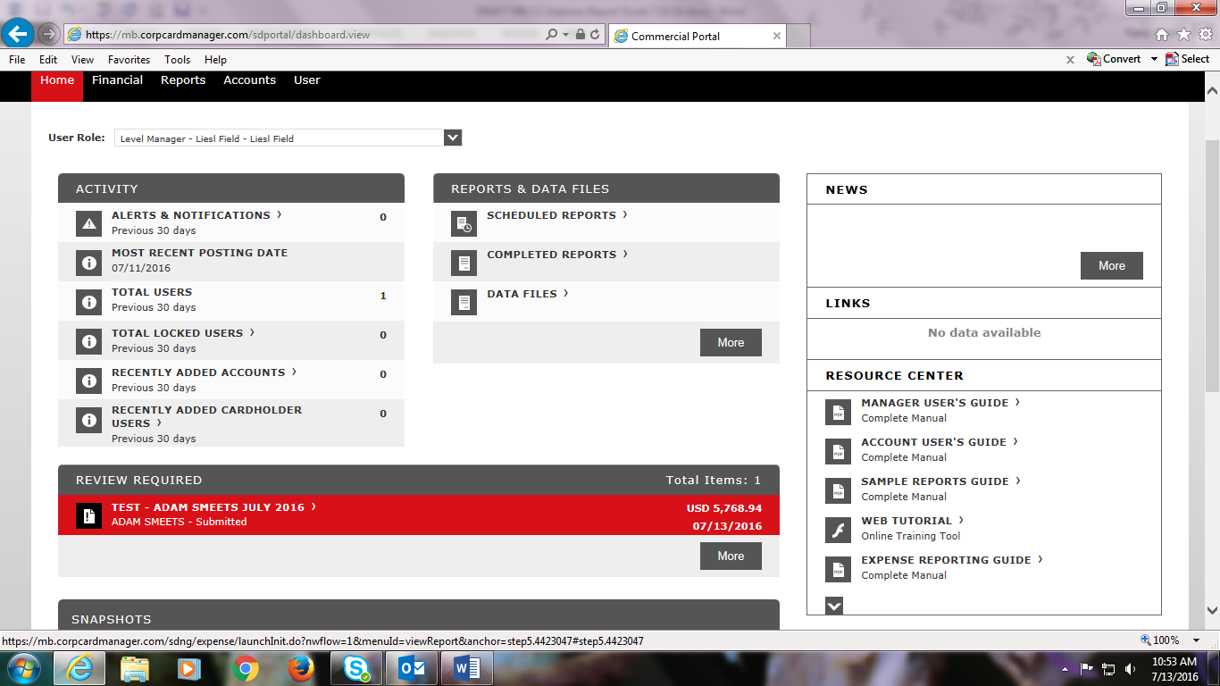
Click on Split and Cost Allocate at the top center of the screen to review cost allocations and receipts.
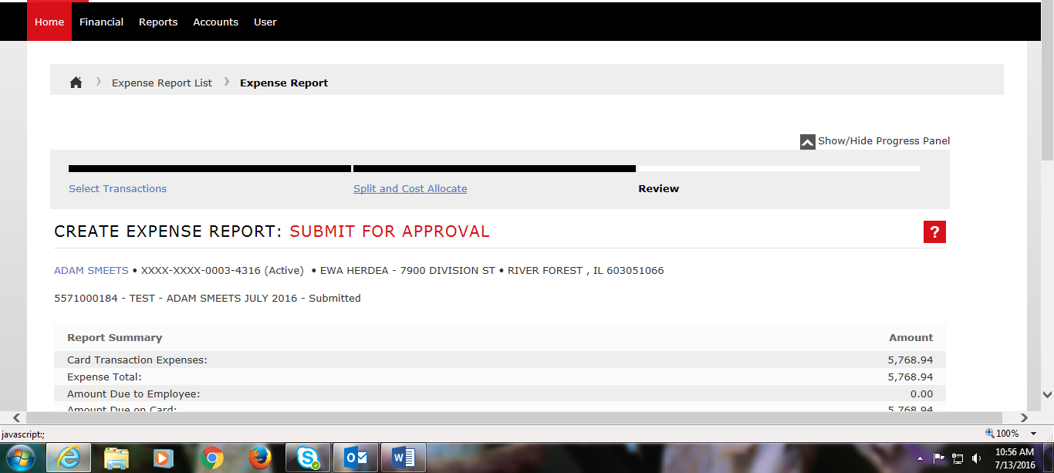

Click on Expand All under Search Results to view all cost allocations at a glance.
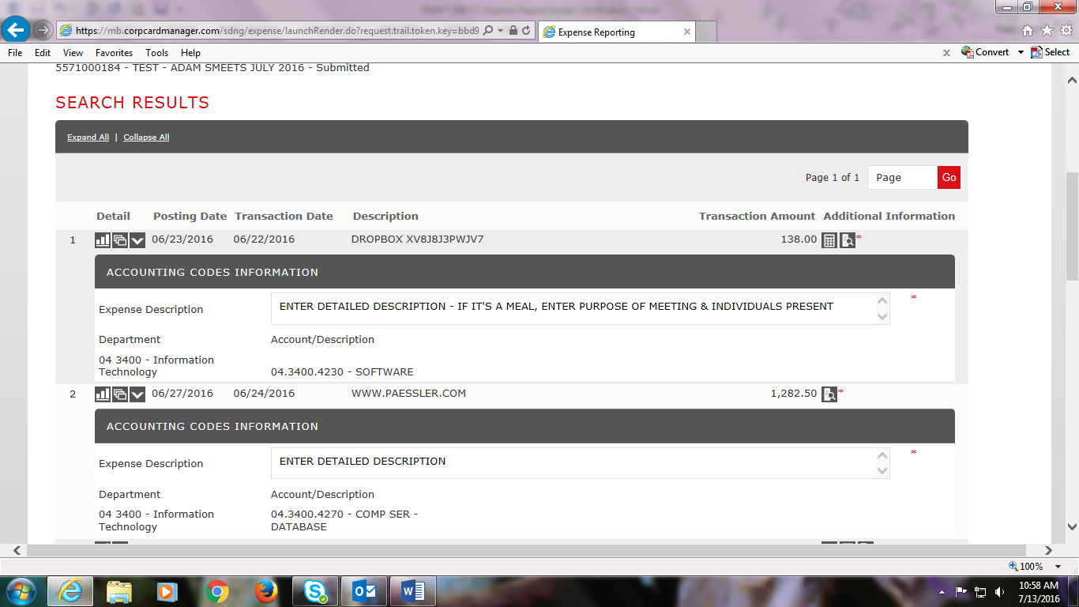

If you need to edit a cost allocation, click Edit Account Code and select the appropriate code.
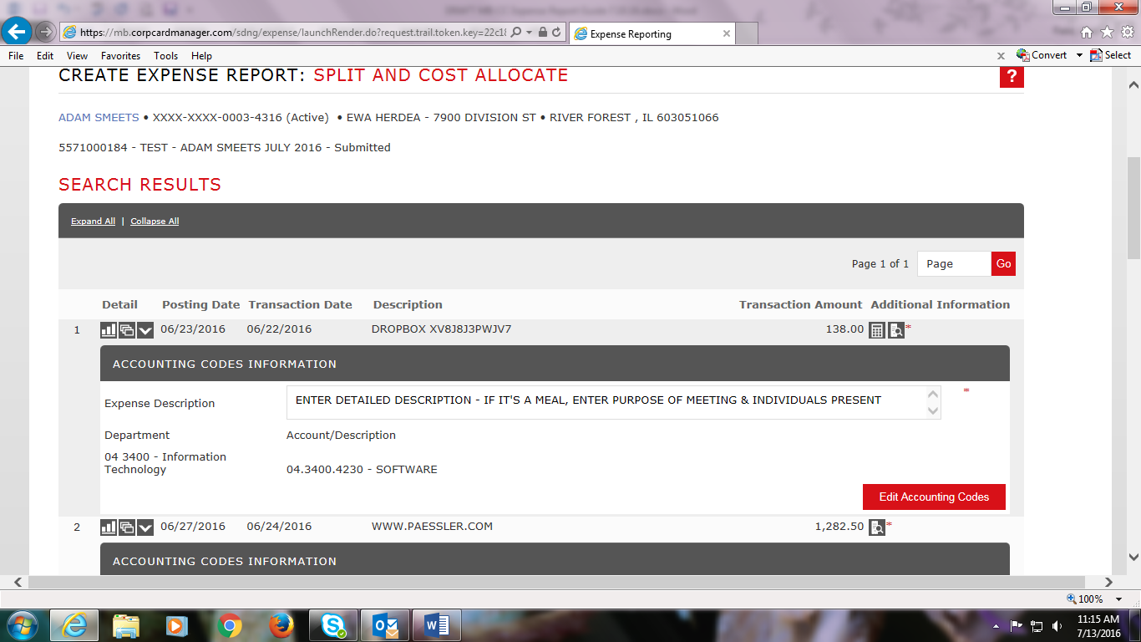

After reviewing cost allocations and receipts, click Next at the bottom of the screen.
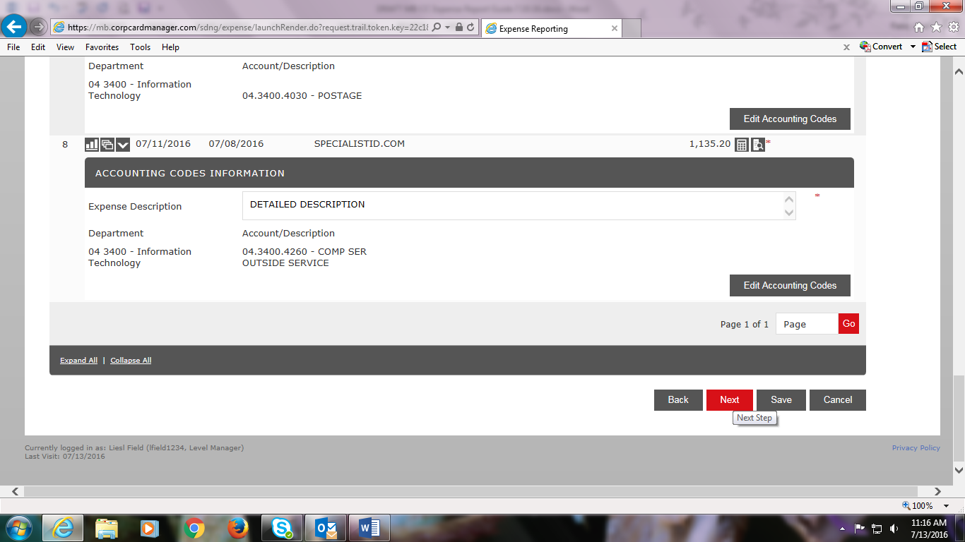

If you need clarification or want cost allocations changed prior to approval, type a message under Comments and click the Reject button.
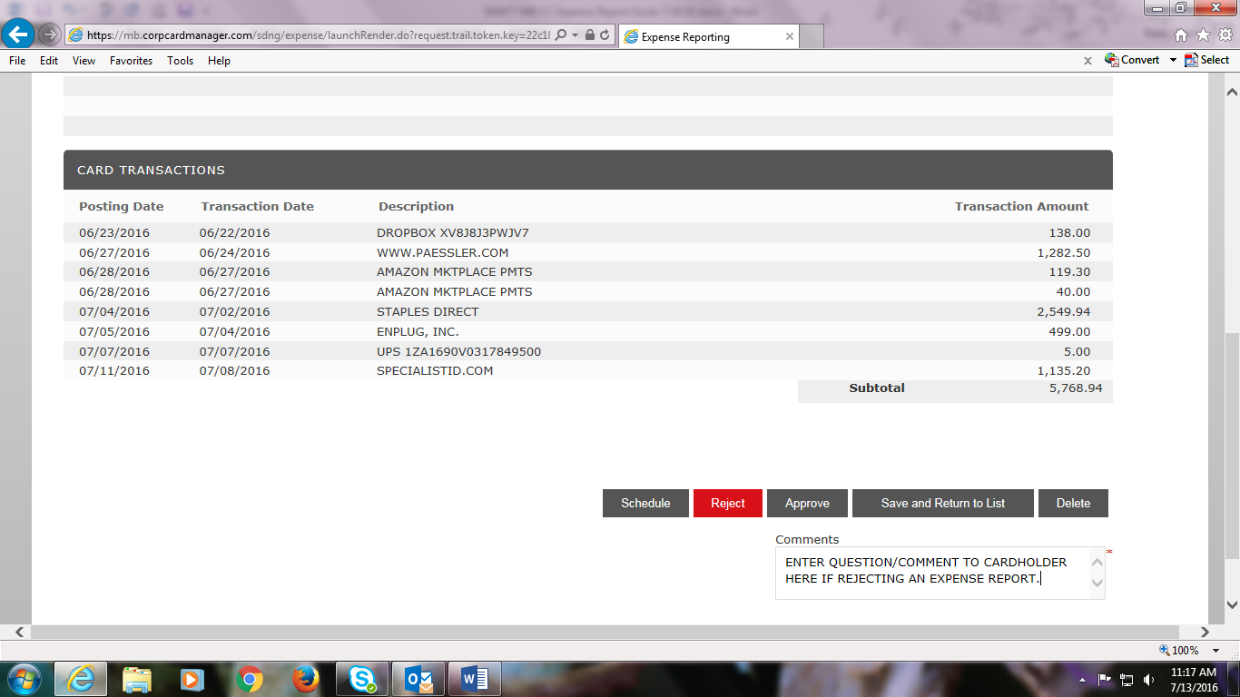

If everything is in order, click Approve.
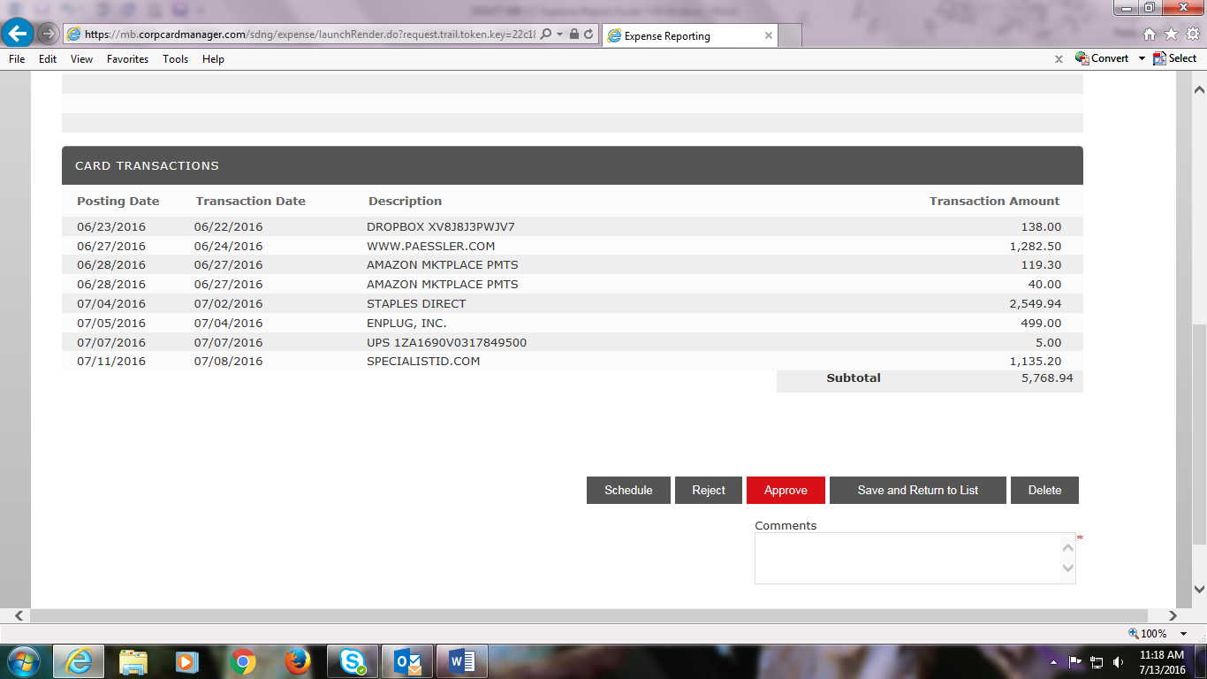
Click OK.
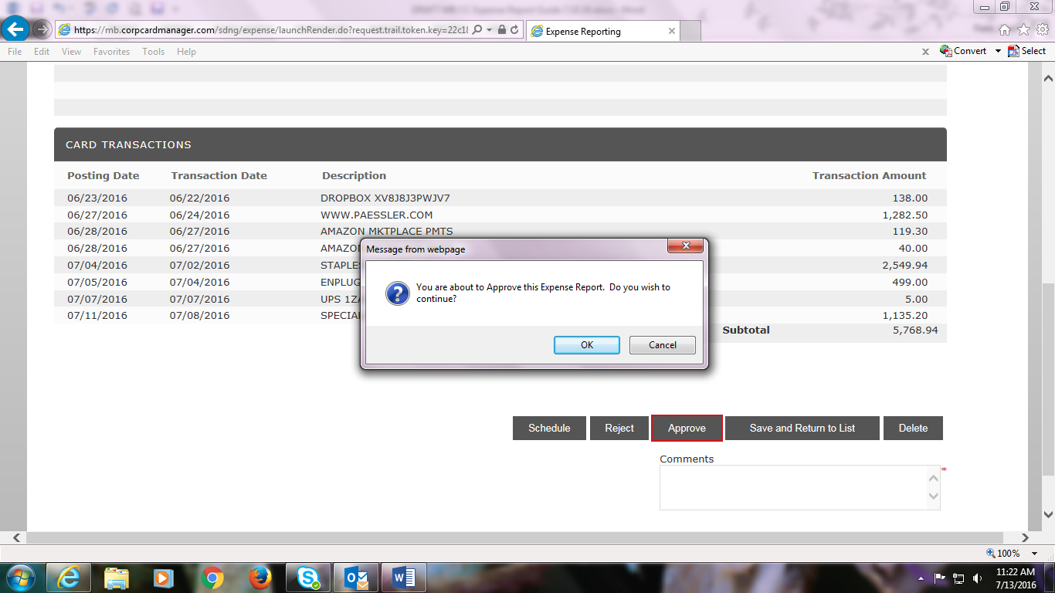

This screen will appear after the approval is processed. In this example, no other expense reports are pending approval so none are listed. The Assigned box in the middle must be checked to approve expense reports (it is checked as the default).
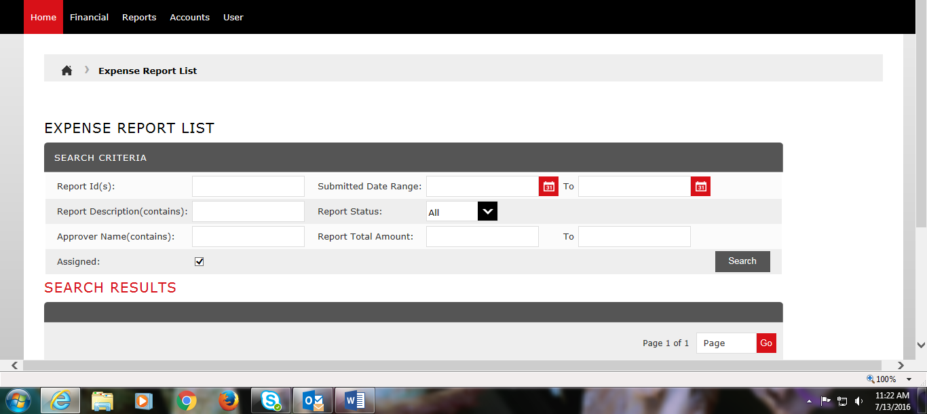
To view any expense reports in progress and not yet submitted for approval or completed and approved reports, click on the box next to Assigned to un-check it. Click Search.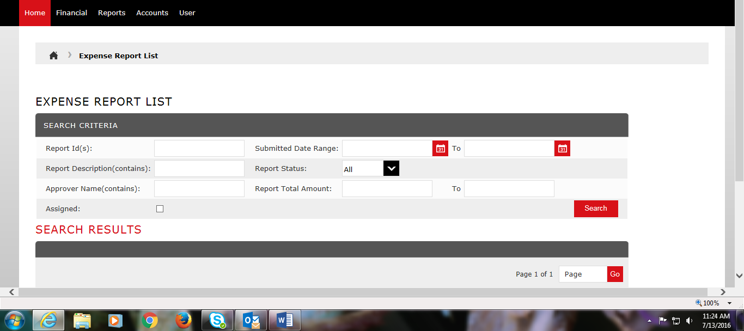

You will see the Approved Expense Report and any Completed Expense Reports. You can click on them to view allocations, receipts, and/or schedule a report to print it out.
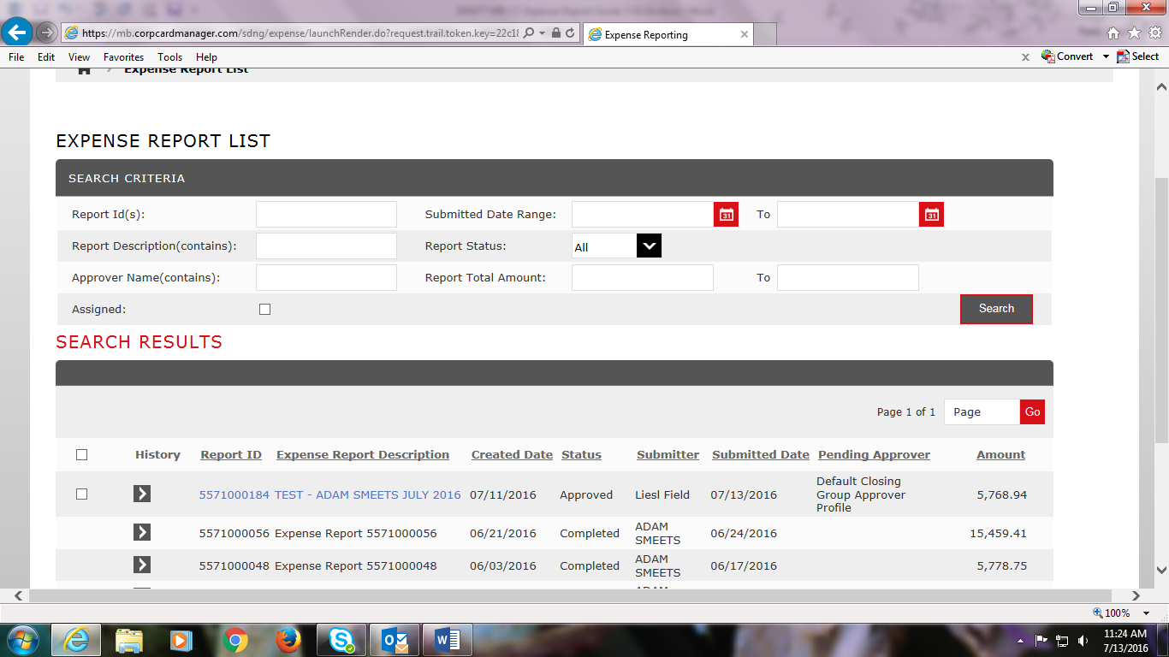

If you want to print out an expense report, click on it, scroll to the bottom, and click Schedule.
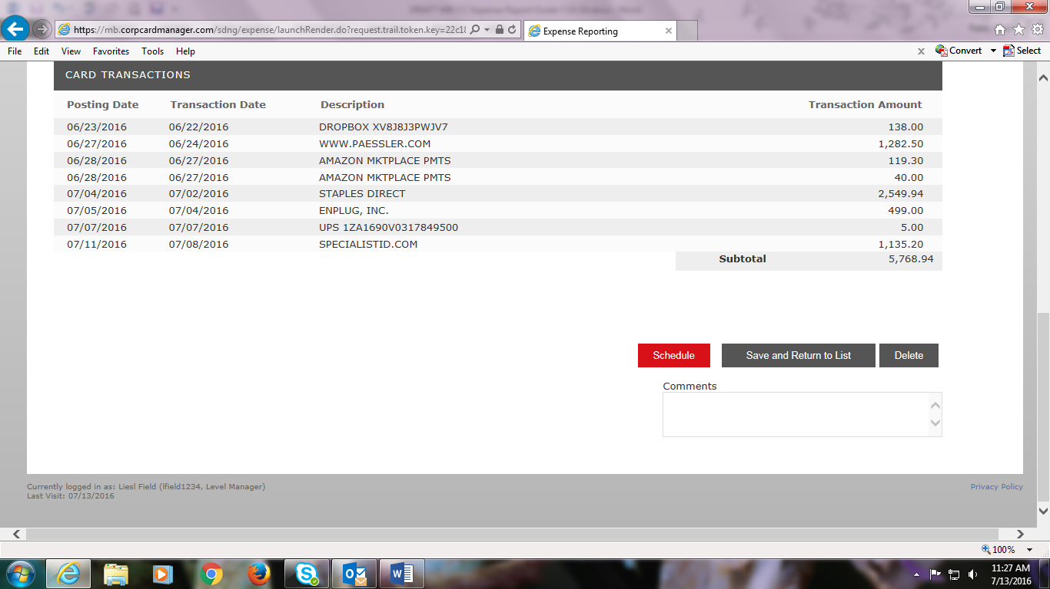

Click OK. 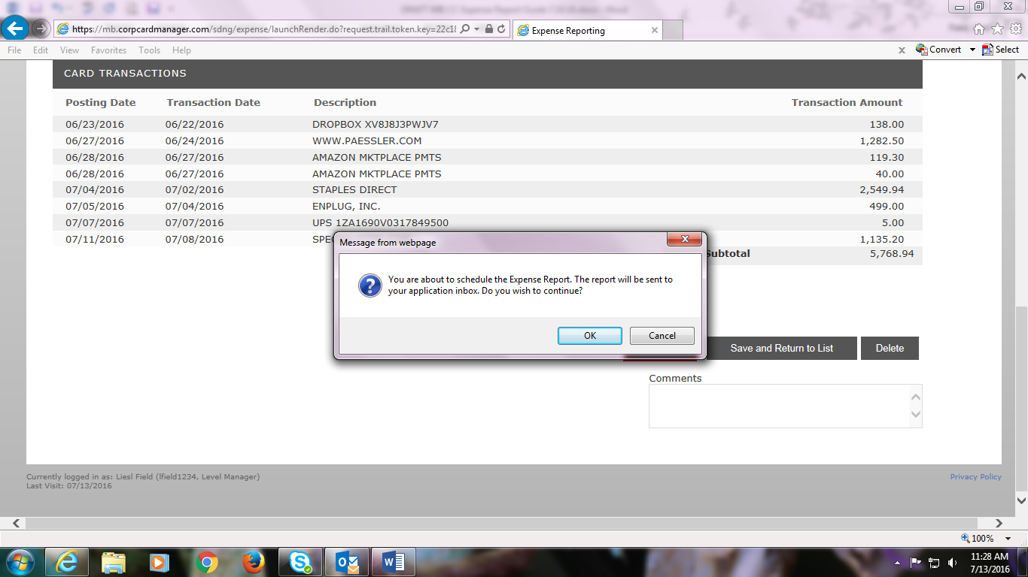

This will schedule a pdf report to be generated.
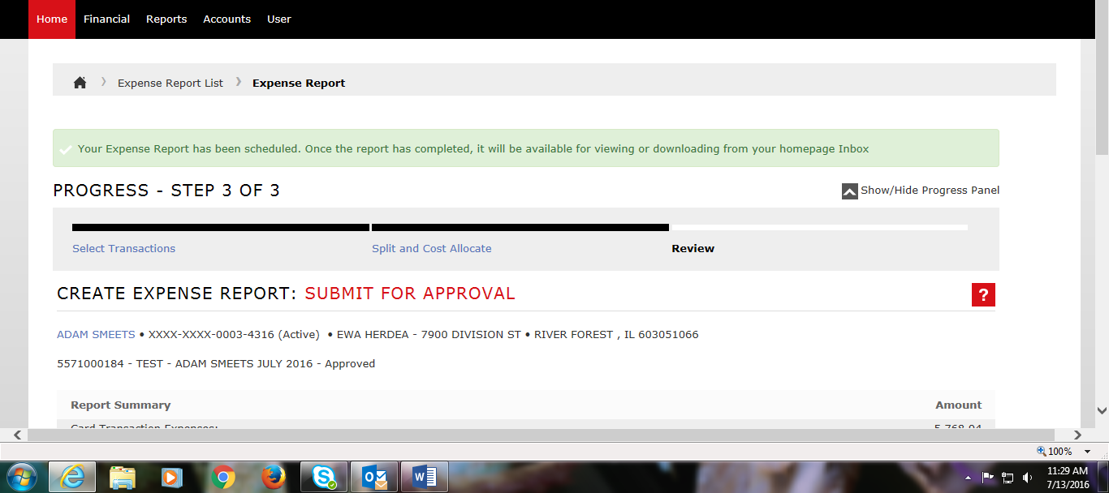

You will receive an email notification when the report is ready. Go to Internet Explorer and log in.
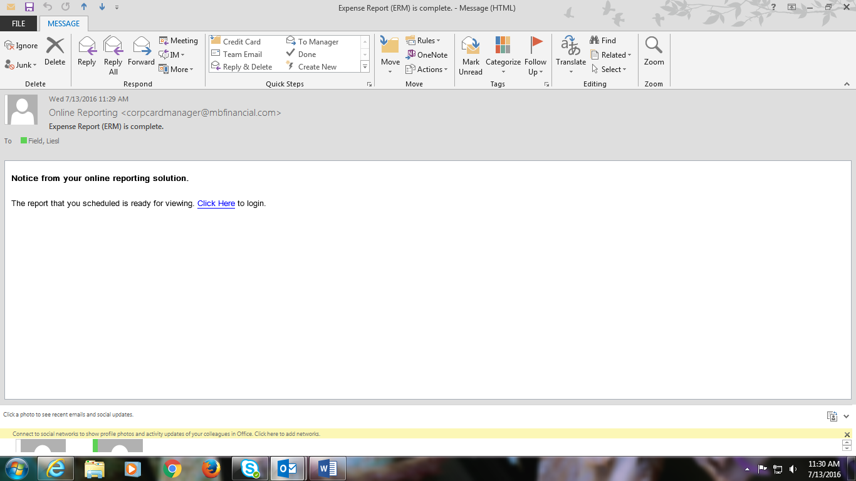

You will see the report under Reports & Data Files.
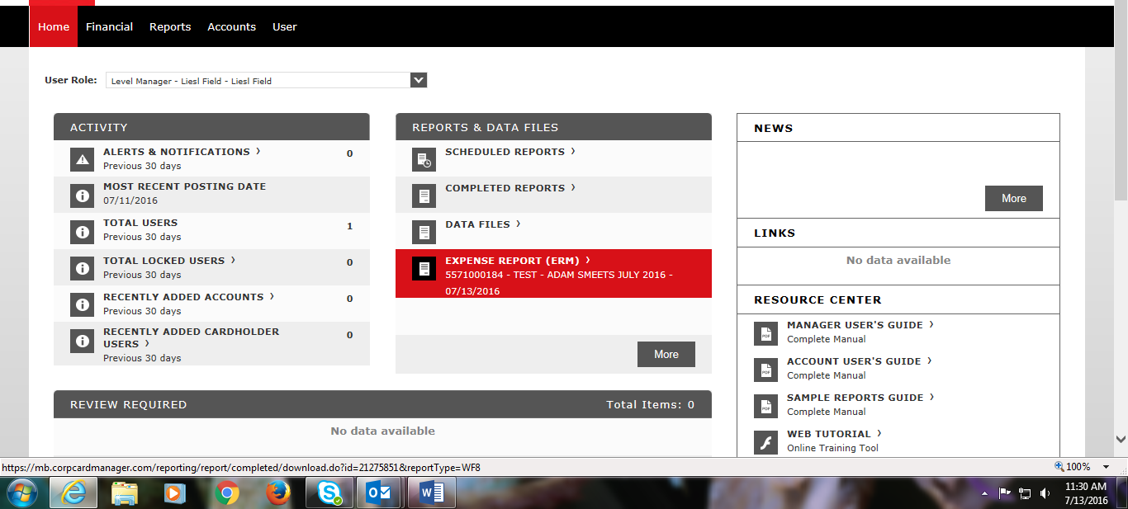

Click the report and click Open at the bottom your screen.
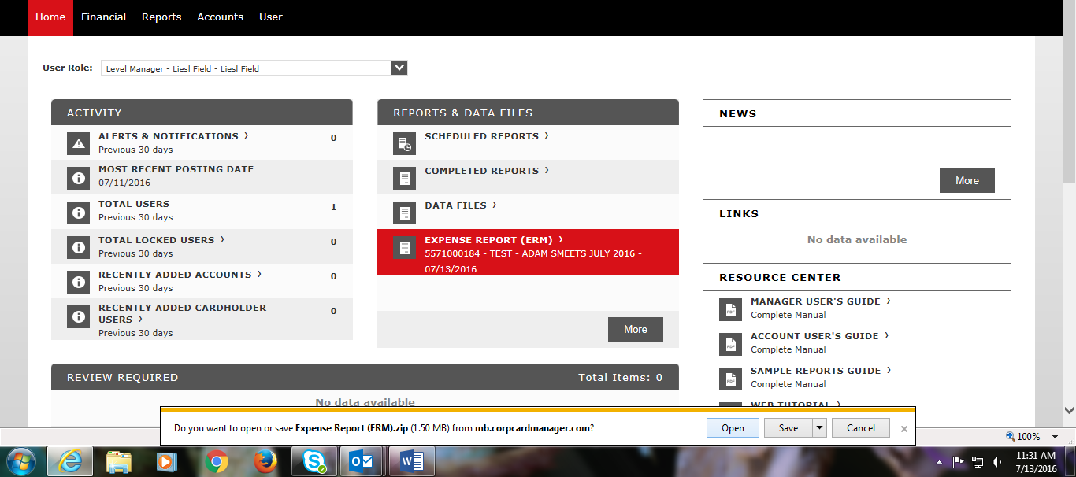

A zip file is generated with pdfs of the Expense Report and all the itemized receipts. Print or save as needed. The FIFTH THIRD portal retains your expense reports for 3 years. The Business Office saves an electronic copy of each monthly expense report/receipts for audit purposes. 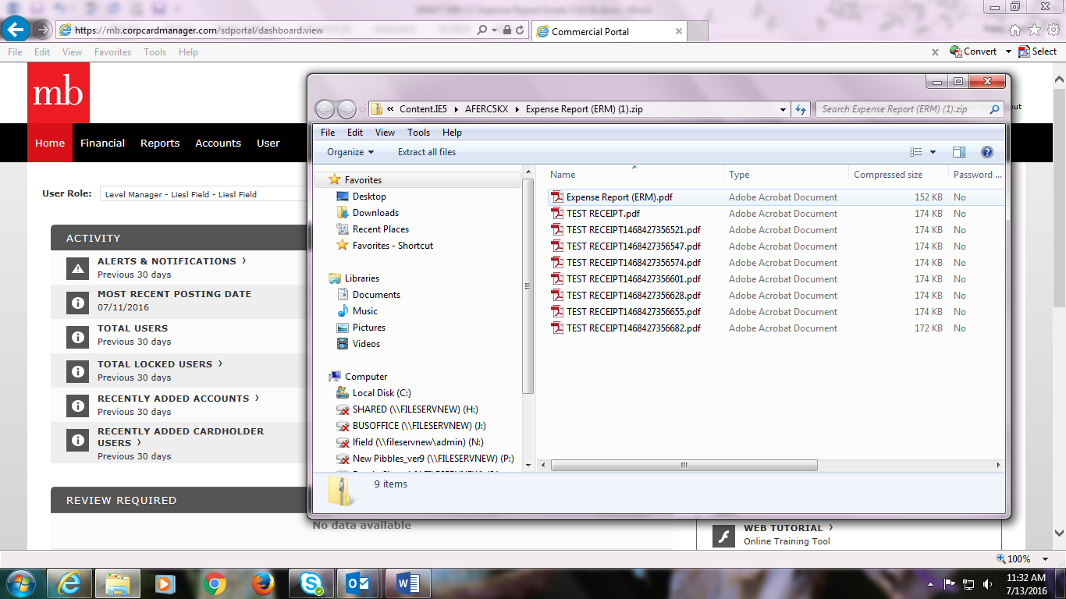

Once a Supervisor approves an expense report, the cardholder and credit card administrators receive an email notification for Final Approval. The accountant is the main card administrator and reviews all transactions and uploads to ensure proper audit documentation prior to final approval. Once approved, you will receive an email notification confirming Final Approval. Your expense report is done!
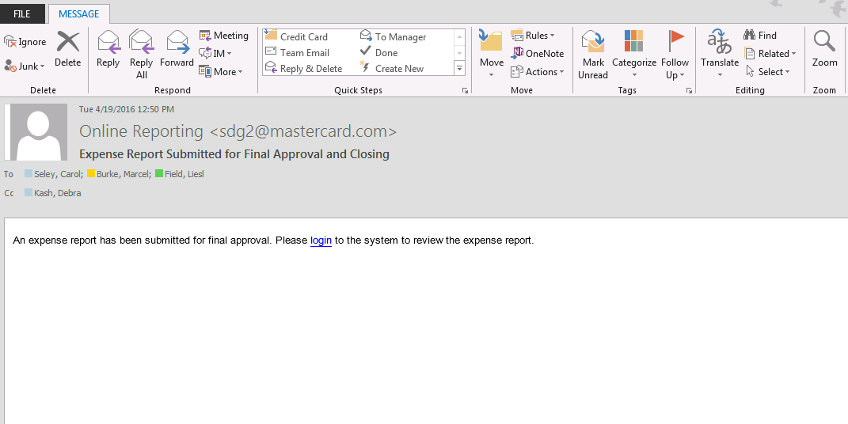

You may have two expense reports at the same time if you are awaiting the end of a statement cycle or pending supervisor approval. To access an expense report that may not be shown on the home page, click More under Review Required.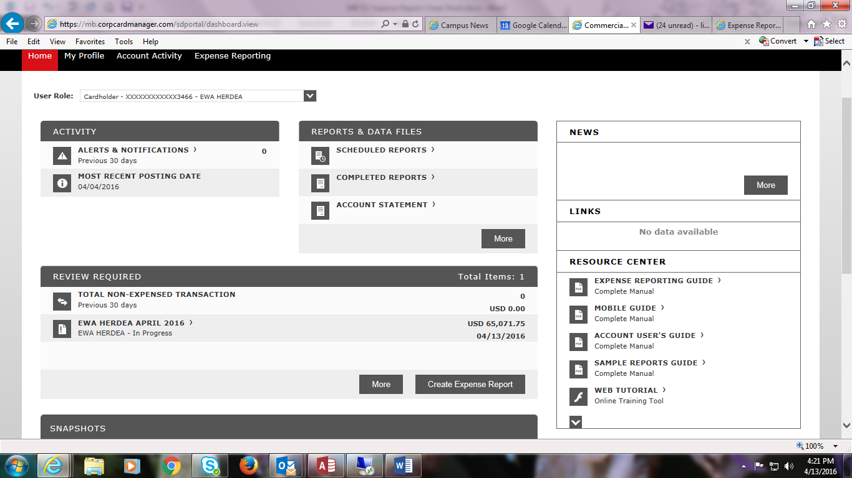

You will see any expense reports created and their status. Click on the one you want.
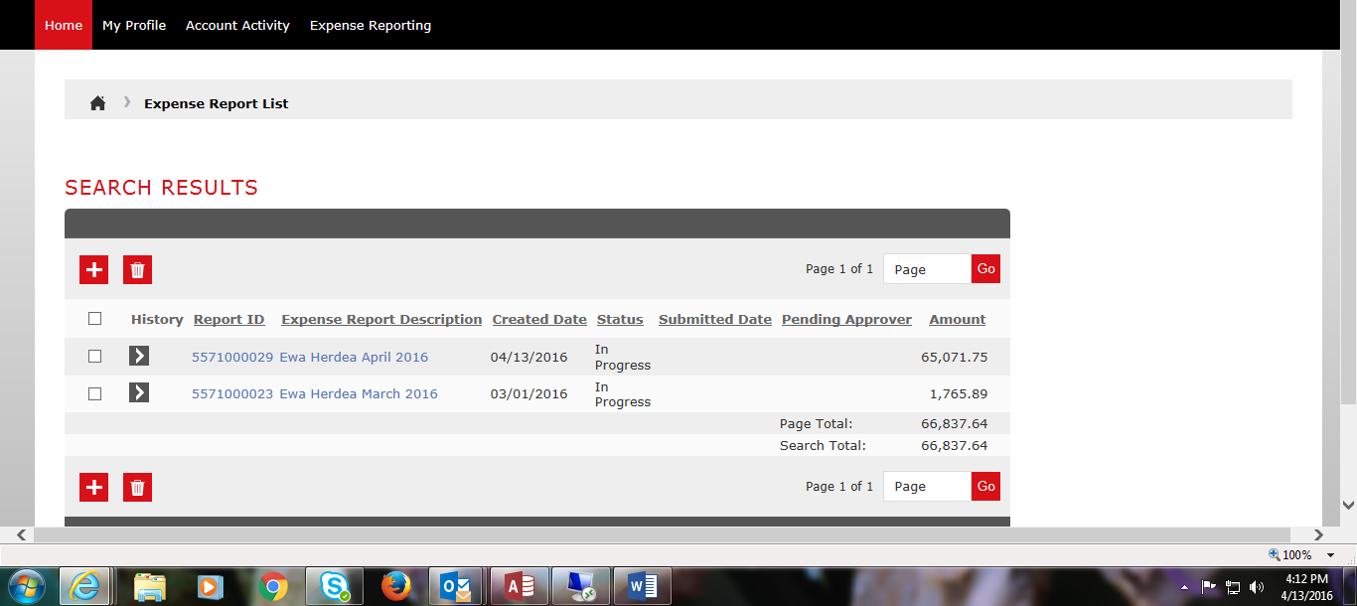

If you click on the March Report you will see the pre-selected transactions within that cycle range
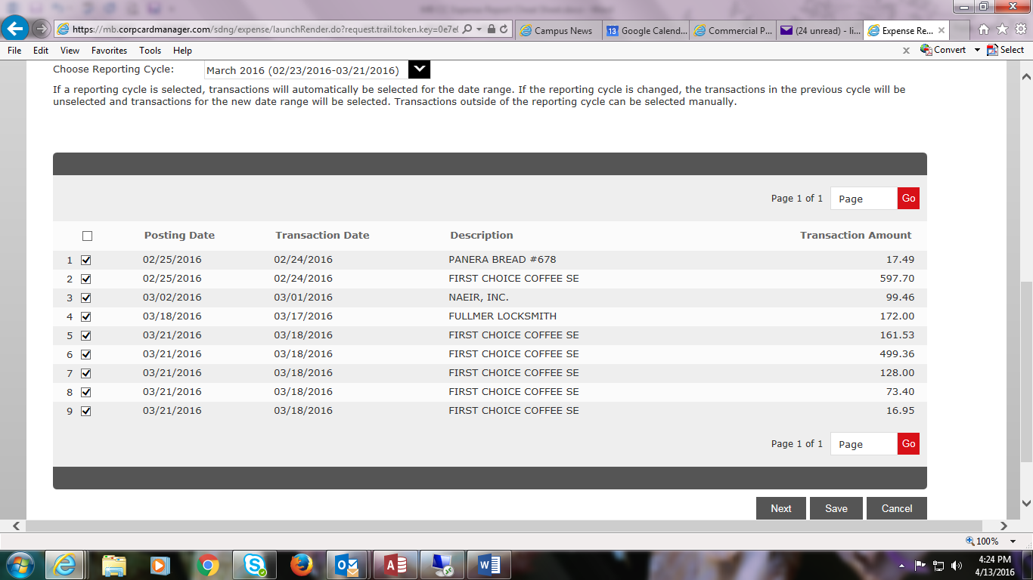

Click Next. This March report has already been cost allocated with receipts uploaded and pending submission for supervisor approval. You can click on the Receipt icon on the far right of each row to View the receipt. You can click on the > icon to see the cost allocation code and description.
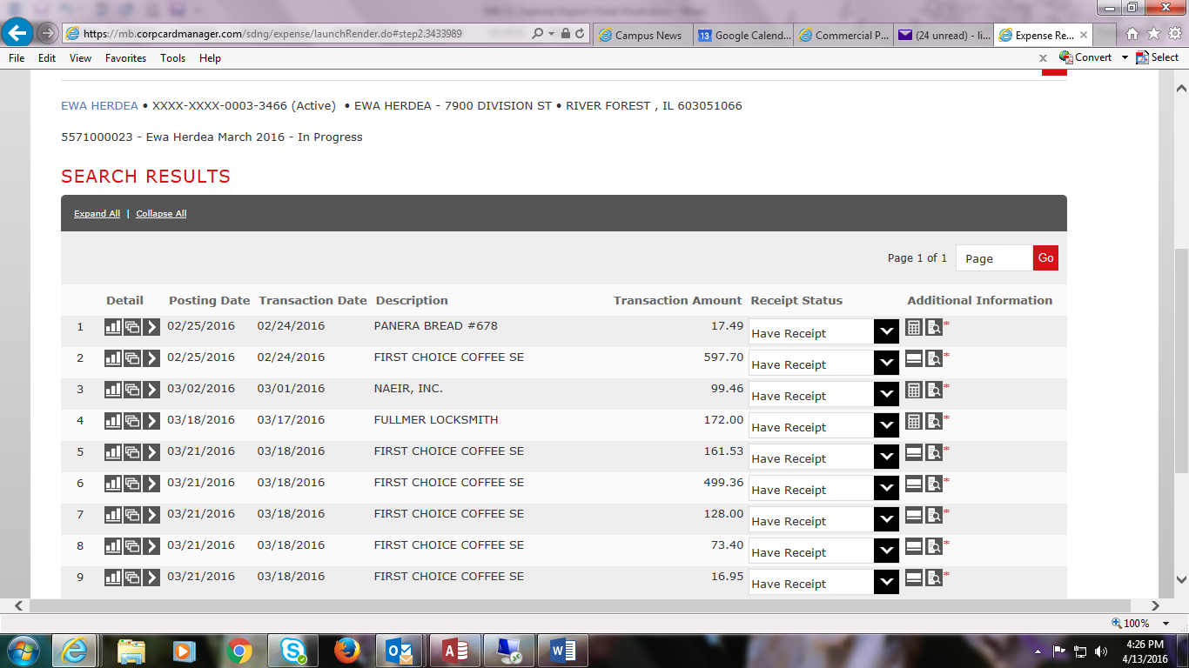
If you are in progress with a report and new transactions have been added since you last allocated items on your expense report, you may need to select them to include them on the correct statement cycle. In this case, the April cycle is 3/22/16 - 4/20/16 per the default drop down menu.
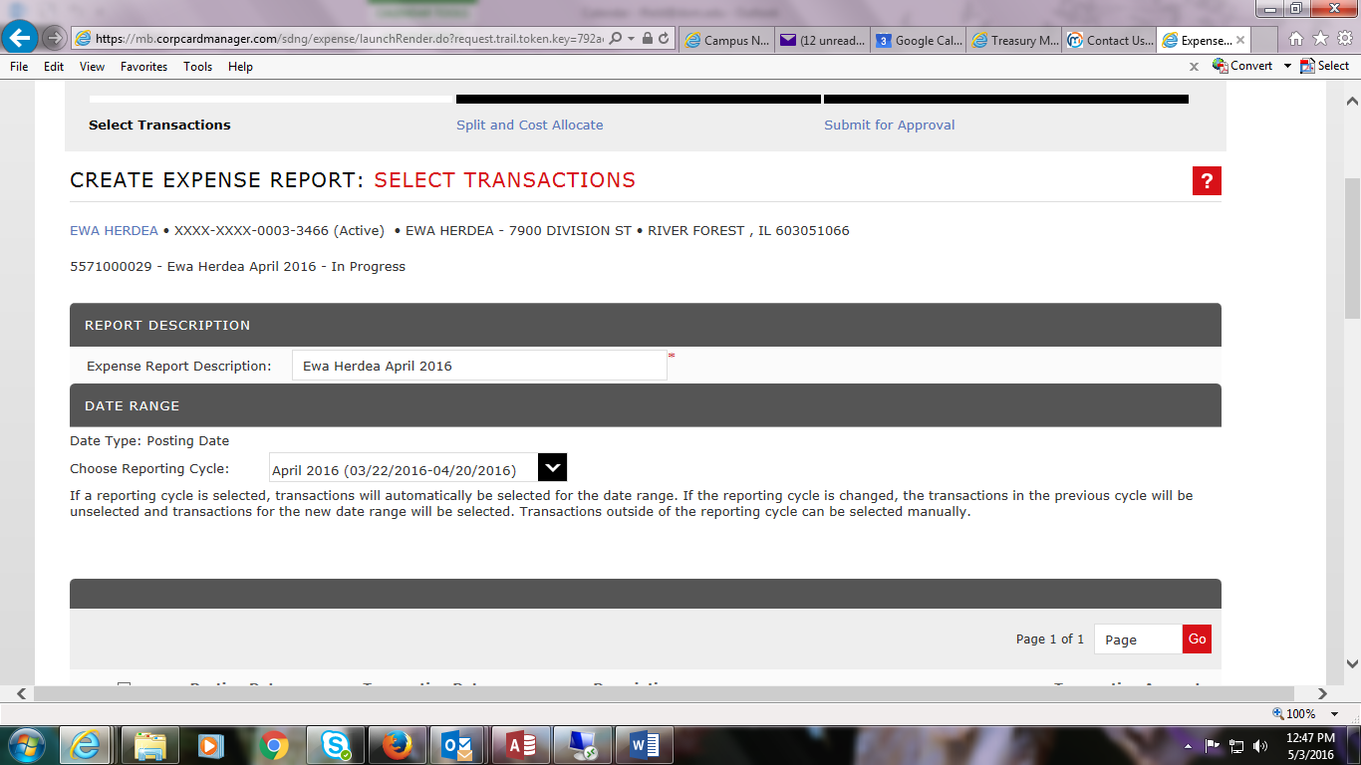
You will note later transactions occurred that fall within this statement cycle range that you must add to this expense report – in this instance, lines 28 and 29 (the 4/18 and 4/19 transactions) fall within the 3/22 – 4/20 range.
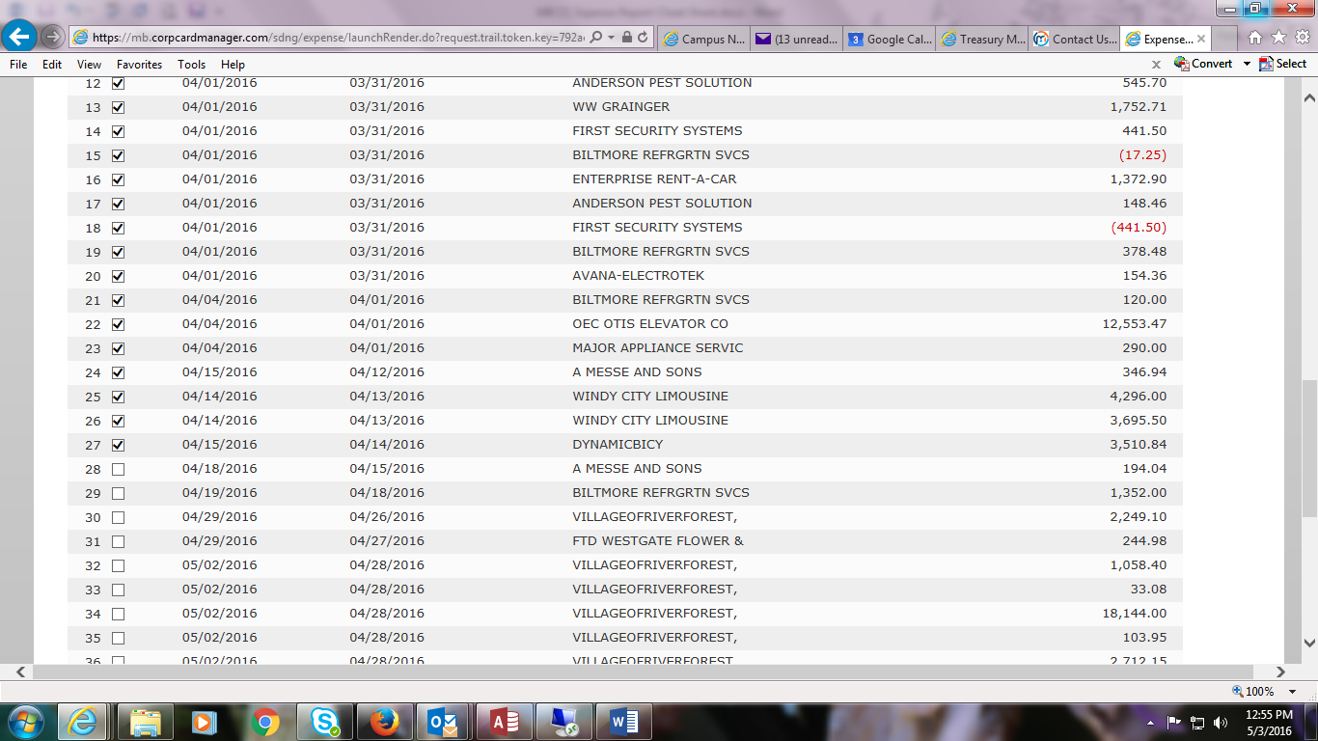
Click to select lines 28 and 29 in this case, then click Next. Now you can upload receipts and cost allocate them.
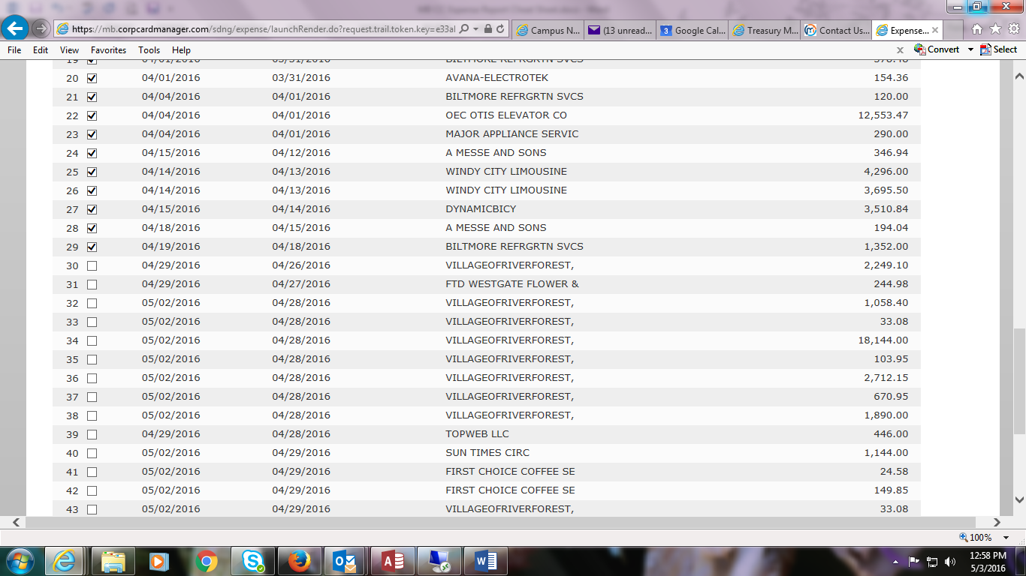
When there are two expense reports in progress and you are ready to submit one when the statement cycle has closed, in this case March, select the one to complete and send for supervisor approval.
Verify that all the dates selected are correct for the statement cycle. If not, click additional transactions, upload/cost allocate them, save, then submit.
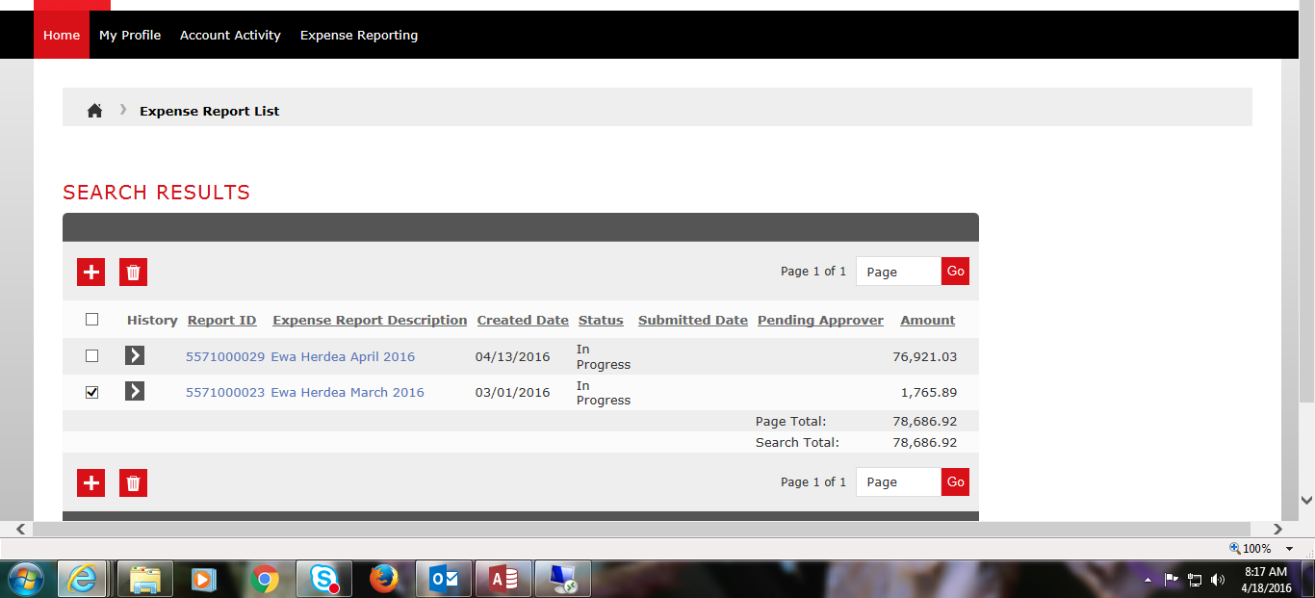
Your Expense Report status is now updated on your list and is shown as Submitted.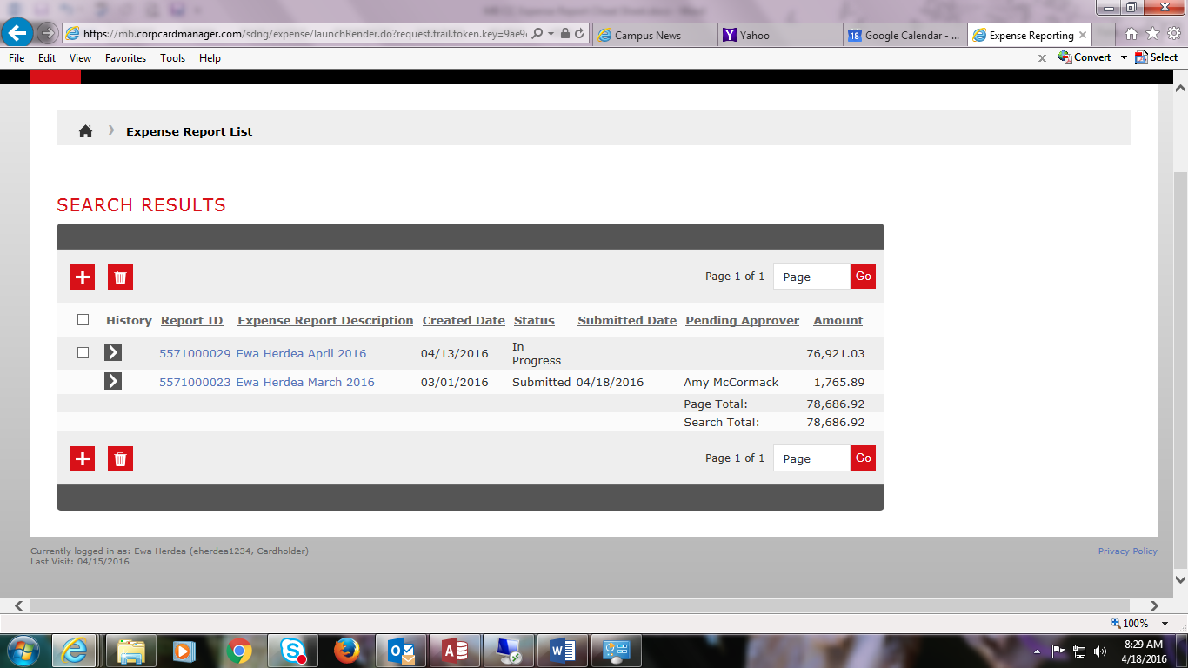

Uploading Mobile Receipts: On your smartphone, go to: https://m.sdg2.53.com/mobile/ and bookmark this site for future access. Log in with your User ID and password – it is case-sensitive.
To upload receipts, click on the three grey bars at the top right corner.

- Click Upload Receipt.
- You can enter the Transaction Amount, Date, and Description.
- Click Choose File.
- Choose to take a photo or use a photo.
- Take a picture or select a picture.
- Click Use Photo.
- Next to Choose File you will see your uploaded file.
- Click Submit.
- Receipt Uploaded Successfully will appear at the top of the screen.
- Please ensure that all information is legible for audit purposes.
- Once uploaded you can attach the receipt to a transaction.

From your computer, log into the FIFTH THIRD portal. To view your mobile uploads, click on Account Activity, Manage Receipts, My Receipts.
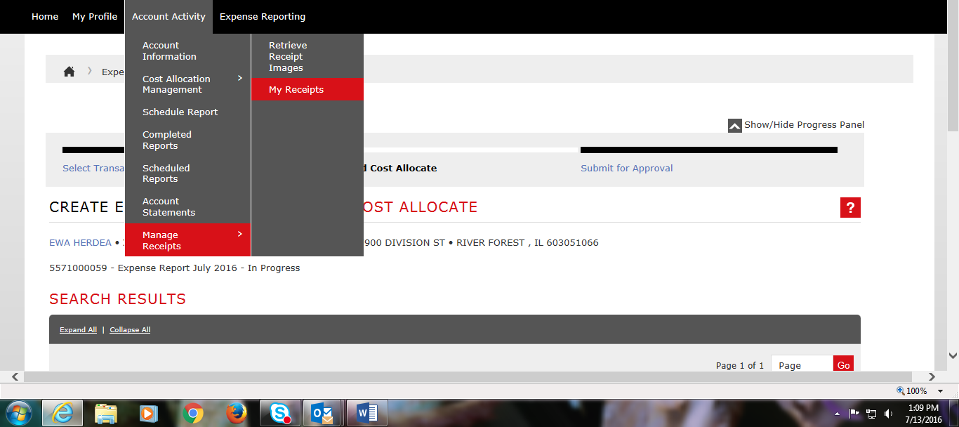

Edit any Transaction information as needed.
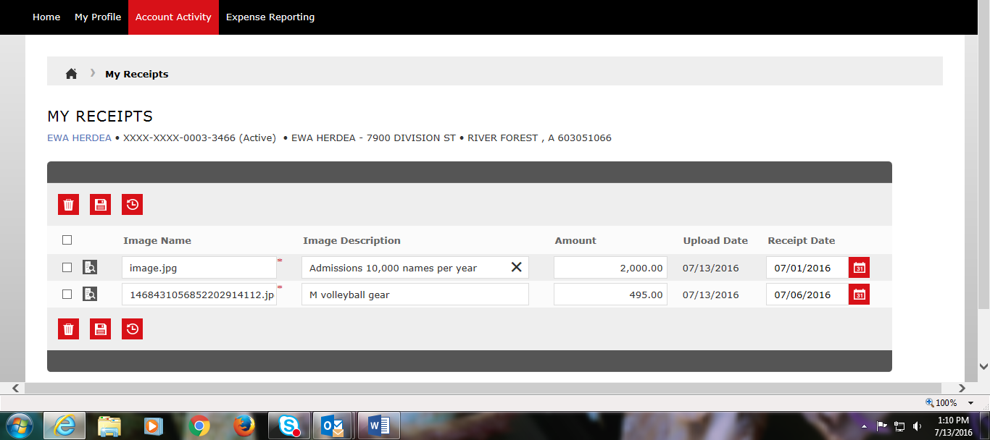

To upload your mobile receipt, find your transaction and click on the far right Mobile phone with receipt icon next to the Transaction Amount. 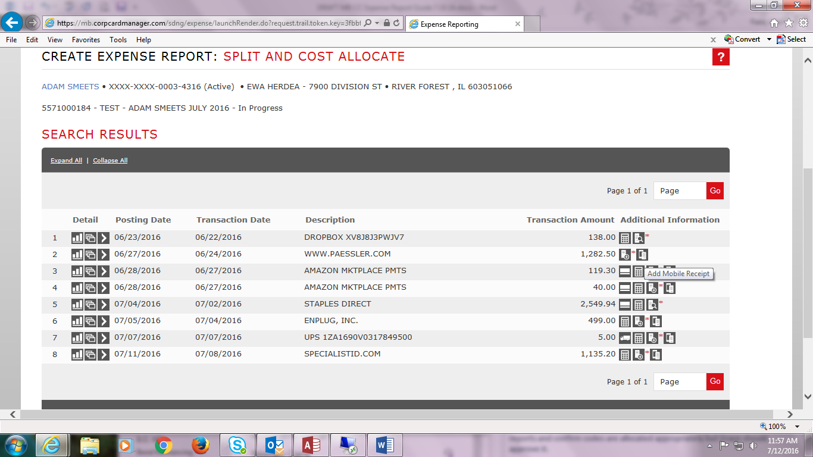

Any mobile uploaded receipts will appear here. You can preview the photo before attaching it to the transaction by clicking the Receipt with magnifying glass icon. To upload your mobile receipt, clicking on the Image Name. It will automatically be removed from your My Receipts screen.
